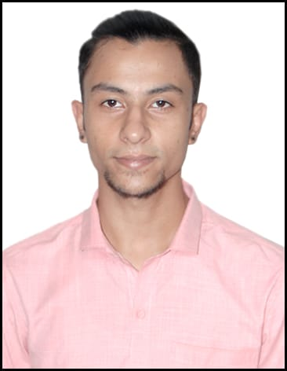 |  |  | arank  OBJECTIVE  To work in an environmentwhich encourages me to succeed and growprofessionally by challenging me and where i canutilizemyskills and workexperienceappropriately  WORK EXPERIENCE  February2017 - September 2018  Staff Supervisor • My job roletherewas to supervise the workers and make sure thattheyserved in their full potential  October 2018–March 2019  Expense Manager • My job role as the expense manager was to maintain a record of the day to dayexpenses and to make sure that all the requiredthings are provided to the general staff and to the kitchen staff. I had to make sure that all the groceryneedswerefulfilled on time  April 2019–September 2019  Assistant Manager • As the assistant manager, myrolewas to ensurethat the rooms of the hotelwerealways clean and up to the mark. I had to make sure that the curtains,bedsheet and the pillowcoverswerealways clean and the room alwayssmellfresh. Customer satisfaction wasmypriority,all therequeries and troubles were to besolved by me. MyResponsibilitywas to make sure theyhad a good experience in the hotel, from check-in till check-out. Be itprovidingtaxi’s or guides itwasmyresposibility.  EDUCATIONAL QUALIFICATION AND EXPERIEnCE  2016- Delhi Public School  High School (10+2)  Pursuing B.A English Literature  1st Year- RDVV (Rani DurgavatiVishwaVidhyalaya)  69%  2ndYear- RDVV (Rani DurgavatiVishwaVidhyalaya)  67.75%  Certification of Experiencefrom the DophinHotel&Family Restaurant.  Communication  I like to lead, an alpha male. Like to getinto conversations and interactwith new people. Being a multi-lingual person ,itmakesiteasy for me to talk to people fromdifferentlocalities. Myagemakesiteasier for me to adapt to new changes and face new challenges and succeed .  Compétences en leadership  I startedworking as a supervisor, and graduallyworkedmyway up to the assistant manager. I have been working on part-time basis since i was a 16 yearold teenager. I am a highly self drivenpersonready to face anykind of challenges thrown on myway to success.
DOB -January 21, 1998
 | Dubai , UAE
 | Arank-394952@2freemail.com
 | English-Hindi-Punjabi-Marathi

PERSONAL DETAILS
NATIONALITY- Indian
GENDER-Male
PASSPORT EXPIRY-07-04-26
VISA EXPIRY- 06-01-19
MARITAL STATUS- Single
WIlling to Work as desired by the by the company.

SKILLS –
Customer Satisfaction
Customer Service
Teamwork
Staffing
Planning
PerformanceManagement
Administrative Assistance
Office Administration
Verbal Communication
Phone Etiquette
Supervision
SkilledMultitasker

