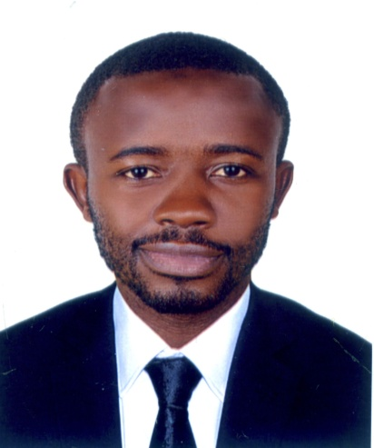 | EUGINE  Email: eugine-394960@2freemail.com  Security Guard  I am, a self-motivated and enthusiastic individual, confident, dynamic, people oriented and good communicator, willing to learn and wishing to pursue a career in an environment where my enthusiasm, sense of commitment and inter-personal skills will make a positive contribution towards organisational growth and profitability as well as self-development.  EMPLOYMENT HISTORY  Experience  Plaza Hotel Bamenda 2014 – 2016  Good Shepherd Academy 2016 – 2019  Jo Responsibilities  - Take usual notes of unpleasant occurrences  - Protect company’s property and staff by maintaining a safe and secure environment  - Act lawfully in defending life and property  - Report detail and suspicious incidents  - Patrol regularly around the building and perimeter  - Monitor and control access into the building even car parks  - Watch alarms or video cameras and detect emergency equipment  - Observe crimes, disorder and disturbances and act swiftly.  - Vigilant in receiving guest even from higher authorities.  Technical courses & Computer skills  Computer Software 2010  Computer Hardware/ Networking 2011  SIRA certification  Hobby:  Research on Latest Technology and Laws  A lover and singer of music  A lover of football
Personal skills
- Assertive and communication skills

- Ability to identify and recognize the clients recorded.

- I am Flexible easily molded to suit company taste
- Team player/Multitasking.

- Quick learner/ Results driven/Goal oriented.

- Passionate and hard worker

AREAS OF EXPERTISE
- Computer skills

- Frst Aid (CPR IN Emmergency) etc

- Fire safety equipements

- Tactfully resolving customer disputes
- Good numerical skills
- CC tv recording
- Active, Ambitious and alert

PERSONAL DETAILS

- Nationality: Cameroon

- Languages: English, French
- Marital status: Single.

- DOB: 05.11.1987.

- Height: 182 cm

EDUCATION

- SIRA CERTIFICATION
- DIPLOMA IT

- ADVANCED LEVEL

