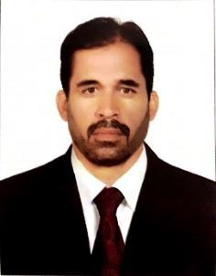

Curriculum vitea

Rashid

Rashid-394964@2freemail.com

(Chauffeur/Driver)

Objective :

Seeking a job in a professional and dynamic organization . Where I have chance to apply my skills and acquire knowledge along with right tools to increase the present value of my organization and consequently myself.

Qualifications :

- Intermediate from University of Peshawar Pakistan 1994.

- Out side plant cable jointing diploma (Telecom foundation Islamabad )

- Office automation course ( MS word, Excel and IT Basic).

Work Experience :

- Worked as a security in charge in AUH Mall 2001 to 2002.

- Worked as a limo Chauffeur in Fast Rent a Car 2004 to 2006.

- Worked as a courier 2006 to 2008.

- Worked as stretch limo Chauffeur in Dubai 2008 to 2017.

Languages :

- Have good knowledge of English,urdu,Hindu written & spoken.

Driving license :

- Holding valid light vehicle license of UAE.

- Good knowledge of various locations in UAE .

Personal details:

✓ Date of birth : 16/03/1974

✓ Religion. : Islam

- Marital status : Married

✓ Nationality |  | : | Pakistan .
Passport details:
✓ | Place of issue | : | Peshawar Pakistan
✓ | Date of issue | : | 29/08/2016

- Date of Expiry : 28/08/2021.

Visa status : visit.

