CURRICULUM VITAE
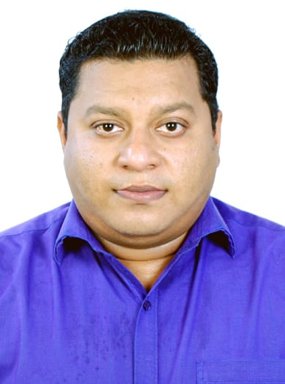
FRANCIS

Dubai, UAE.

Email ID: francis-394975@2freemail.com

Visa Status: On Visit (Upto 31-oct-2019)
Post apply for any suitable job.

Career Summary:

Having Thirteen years’ experienceas a waiterto be work in a position as a meaningful and challenging, that enables me to develop myself as a professionally. To obtain a suitable position in an esteemed organization, where I can utilize my qualification and experience to carry out my duties efficiently and develop a successful carrier.

Academicqualification:

Course:Diploma in Craftsmanship course in Food production and Patisseries.
Institute:Institute of Hotel Management Catering Technology and applied Nutrition's, Goa, India.
Course Duration:2004- 2006.

Work experience:

Company : in Goa, India. (January 2012 to June 2019)
Designation : Captain.

Company: Restaurant in Dubai, UAE. (March 2010 to November 2011)
Designation : Waiter.

Company : Resort in Goa, India(May 2008 to Dec 2008).
Designation : Waiter.

Company : Beach Resort in Goa, India. (Nov 2005 to Feb 2007.)
Designation : Industrial Trainee.

Job responsibility:
- Greet and escort customers to their tables.

- Present menu and provide detailed information when asked (e.g. about portions, ingredients or potential food allergies).

- Prepare tables by setting up linens, silverware and glasses.

- Inform customers about the day’s specials.

- Offer menu recommendations upon request.
- Up-sell additional products when appropriate.

- Take accurate food and drinks orders, using a POS ordering software, order slips or by memorization.
- Check customers’ IDs to ensure they meet minimum age requirements for consumption of alcoholic beverages.
- Communicate order details to the Kitchen Staff.
- Serve food and drink orders.
- Check dishes and kitchenware for cleanliness and presentation and report any problems.
- Arrange table settings and maintain a tidy dining area.
- Carry dirty plates, glasses and silverware to kitchen for cleaning.
- Follow all relevant health department regulations.
- Provide excellent customer service to guests.

Computer skills:

- Diploma in computer Application (Microsoft office Word, excel &Outlook)

Key skills:

- Attentiveness and patience for customers.
- Excellent presentation skills.

Personal details:

Date of Birth: 12th Oct 1986.

Nationality : Indian

Marital Status : Single.

Languages known : English, Hindi, Konkani and Marathi.

Declaration:
I, hereby solemnly declare that all the above information is true to the best of my knowledge and believe.

