PERSONAL PROFILE

Date of Birth

22-Mar-1995

Religion

Islam

Marital Status

Single

CONTACT

EMAIL:

Ahmad-394979@2freemail.com

LANGUAGE

English

Urdu

Pashto

AHMAD
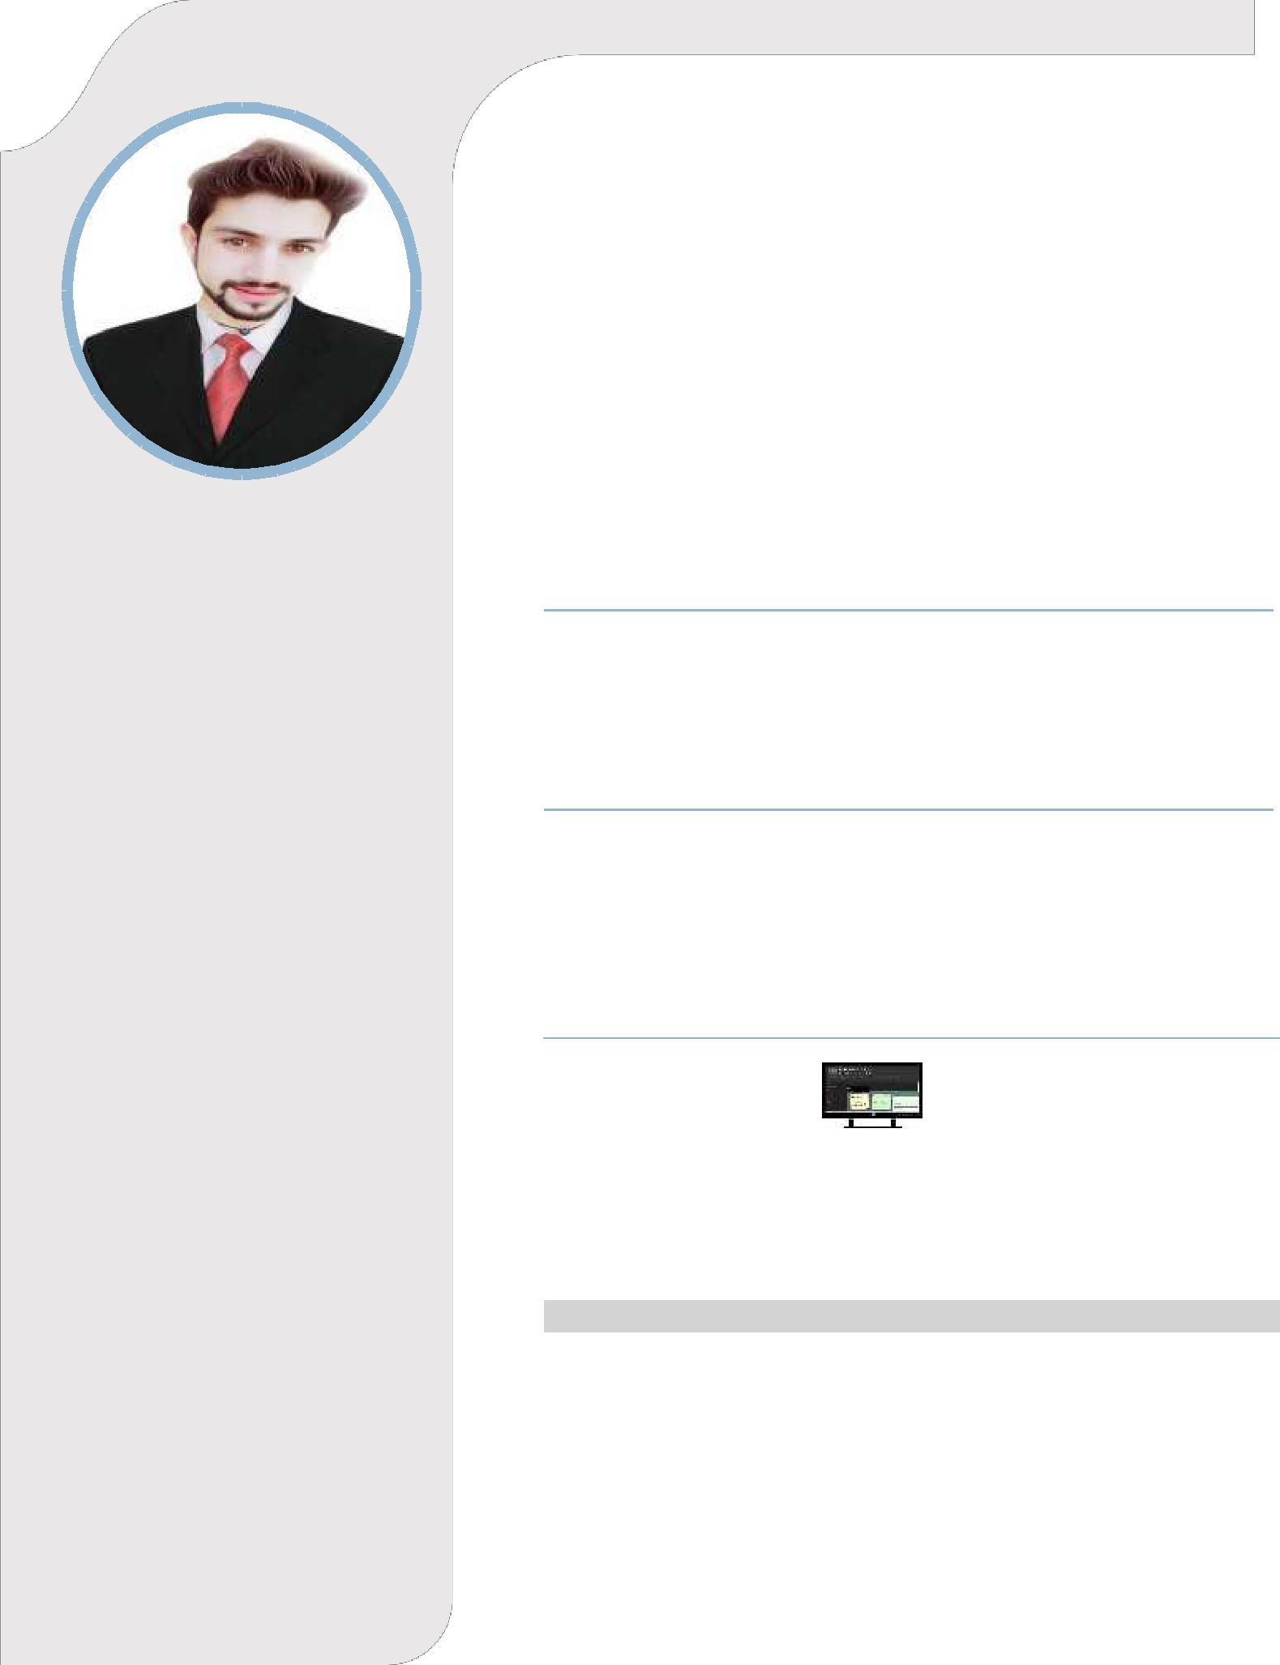
To enhance my knowledge and capabilities by working in a Dynamic Organization that prides itself in giving substantial responsibility to new talent.

EDUCATION

▪ | 2014 – 2018 | BSCS Preston University, Karachi
▪ | 2012 – 2014 | Intermediate Al-Asar Acedmey Usterzai Kohat
▪ | 2010 – 2012 | Matriculation Al-Asar Acedmey Usterzai Kohat

WORK EXPERIENCE

- Work Experience as Computer Technician. From 1 October 2018 to 30 June 2019

- Internship and worked on Software Internet. From 1 July 2017 to 30 September 2017.

PROJECT’S

Final Year Project

April to September Title Digital Media Notification System Oct-Dec 2015 Worked on Open GL Project, Preston University of Kohat

Project Title Developed Football ground in Computer Graphics

Android Application Projects

Android Application AutoCAD in Urdu Android Application Mehndi Design (Pic Studio)
Android Application Digital Media Notifications System (DMNS)

Android Application Odaari (Rent and Sell)

TECHNICAL QUALIFICATION

- 6 Month Diploma in peach tree. (From Global instituade kohat)
- Web Developing And Design

- Html and CSS

- Wordpress

- Search Engine optimization (SEO)

- Adobe Photoshop

- Corel draw

- IN page

- MS Office Suit

- C and C++

- VB.Net

- Corel Video Studio x8

- U lead Video Studio

Worked on Web Development Projects Web Base Projects and Connect his Hyperlinks

PROJECT TITLE |  |  |  |  |  | DATE
PICBAXAR |  |  |  |  |  | December 2017
KARACHI BUS ROUTES |  |  |  |  |  | January 2018
ODAAR |  |  |  |  |  | March 2018
AHMADALI |  |  |  |  |  | July 2018
OUR QUESTIONS |  |  |  |  |  | Aguste 2018

Local Host Websites

PROJECT TITLE | DATE
PRESTON | May 2017
UNIVERSITY
LIBRARY
SASTA BAZAAR (E- | October 2017
COMMERCE SITE)
HUMTUM (SOCIAL | December 2017
SITE)

PERSONAL SKILL

Highly motivated and eager to learn new things.

Strong motivational and leadership skills.

Ability to produce best result in pressure situation.

Excellent communication skills in written and verbal both.

Ability to work as individual as well as in group.

REFERANCE

Reference will be provided on request.

