Summary

Highly ambitious with background in sales, marketing and advertising. Expertise in market analysis, forecasting and client needs assessments. Experienced professional with strong leadership and relationship-building skills. with strong background in management, supervision, training and customer service. Customer-oriented with strong history of leading high-performance teams to meet or exceed objectives. Dedicated and hardworking with internal drive to deliver excellence. Tactical team builder with strong background in training and team developmen

Skill Highlights

|  |  |
| --- | --- |
| * Data Management * Data Entry * Sales & marketing * Casher * useful comments in the field of work | * Team management * Research * Microsoft Office * I can work under pressure and long periods |

Experience

04/2010 to 09/2019

**Administrative Employee**, Egypt

* He joined the Data Entry 2010 as a team manager until 2019.
* I joined a data entry function and then became an administrative development officer and then became the head of the data entry team.

**Carnival store in Alexandria** – 2004 To 2012

**Clothing store manager**

I was working in a clothing store for 6 years and then I was promoted to become the shop manager in the third year until 2010

**My Personal Auto Car** 2014 to 2018

**Used Car Sales**

Education

**Bachelor's in Management Information Systems and Computer Alexandria Academy For Management, Accounting & Computer - Egypt**

2004 to 2008

Contact

**Address:**

Deira, Dubai

**Email:**

[Fayed-394980@2freemail.com](mailto:Fayed-394980@2freemail.com)

Languages

Arabic

English

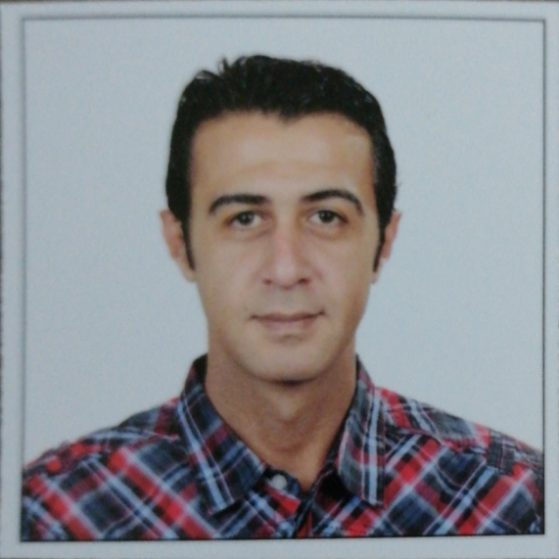

**Fayed**