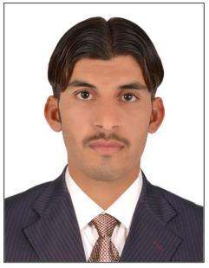
Tamoor Sultan

RESIDENTIAL ADDRESS

(SHARJAH)

I’m on visit visa

Contact : +971553478557

+923004031799

tamoorsultan786@gmail.com

Objective And Profile

To obtain a career oriented position in a professional progressive organization where I can execute my duties in a manner to gain exposure to latest Technical and Management systems, advance skills, self-confidence, growth and prosperity.

Personal Information:

- ➢ Father s Name : Mumraiz Khan
- ➢ Gender : Male
- ➢ Date of Birth : 28 Sep 1990
- ➢ Passport No. : BS5779832
- ➢ Exp. 23 Aug 2026
- ➢ Religion : Islam
- ➢ Marital Status : maried
- ➢ Nationality : Pakistani
- ➢ Languages Spoken : Urdu –English
Academic Qualification And Trainning

1. | Diploma of Associate |  | Engineering (Electronics)
2. | Graduation | First semester had |  | completed
3. | Computer'sActivater |  | 01.jan.2010 TO 30.06.2010
4. | Basic fire fitting | 15 feb 2018 |  | E.F.R.C (Emirates Firefighting And Rescue company) (UAE

Driving Licence Detail :
LTV Licence no : 668682 Expiry date: 03 sep 2020

Experience:

1. | Cell Beam Middle East (Dubai) ( Dec 2012 to Oct 2014 )
2. | Unger Steel Middle East FZE (Sharjah) ( Nov 2014-June2019 )

