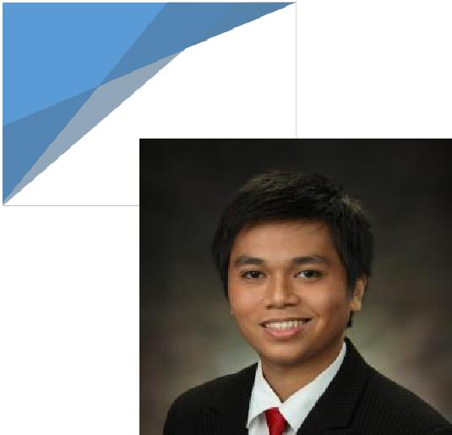
1
John Paul
Work Summary

JOHN PAUL

SENIOR SYSTEM ENGINEER

Email: johnpaul-395003@2freemail.com

Career Snapshot

A dynamic and tech savvy Engineer professional with more than 5 years of experience in Electronics. Interested to pursue a long-term career in hardware & software engineering, and programming and other related openings. Passionate about implementing and launching new projects. Ability to translate business requirements into technical solutions.

Skills and Interests

- Experienced in AWS – Amazon Web Services ECS

- Knowledgeable in C++/Java/python software development.

- Exceptional math and problem solving

- Enjoys facilitating, leading and working in a group

- Knowledgeable in multimedia arts in digital and video editing using Adobe Photoshop, Premiere and Avid Media Composer.

Certifications

- Motorola Radio Certification - Sales and Commercial - Certified Radio Professional (Sept 2018)

- Spearhead HR Training - Train-the-Trainer Program for Management Skills (Sept 2016)

- Electronics Engineering Board Passer – Philippine Licensure Examination for Engineers (Oct 2012)

Undergraduate Thesis

Title: Vessatire – (C# & Eclipse Database) Virtual Dressing Booth and Digital Advertisement - June 2011 – Mar 2012

- Application for convenience of clothing consumers by means automatic scaling of outfits thru a monitoring screen.

- Database for Clothing lines.

- Selected as one of the best and innovative thesis of the Engineering department.

RESUME

2
John Paul
Work Summary
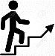

Work Experience

Senior Systems Engineer - Aug 2018 – Present

Core member of Research and Development team – Software whose responsible in analyzing new technologies for Telemetry and tracking services, monitoring and administration of web platform and mobile apps, security and encryption of all software products, and, assistance on sales and marketing for any upcoming bids and projects. (R&D Team – Software)

Key Tasks and Achievements:

- Designed and maintained up to date training curriculum for new engineers with regards to GPS and Satellite devices as well as the procedures in using the tracking platform.

- Minimized the cost of using secured and highly reliable domains and hosting Platforms for our web tracking platform (Azure, AWS, GoDaddy, HostGator, and, Network Solutions).

- Supervised the used of Google and iOS developer accounts for deployment of mobile applications as well as generating security protocols and found a way to create analytics report for mobile app users that helped the app to upgrade its features in line with its clients.

- One of my key task is to facilitate a new project for Web and Mobile platform for Travel Risk Management and Tracking called ‘REACH’ using project management tools such as JIRA and Confluence. Assisted with the server structure of Web and Mobile using Amazon ECS for a scalable and easy to manage system.

- Managed and created manuals for Real-Time Location Services (RTLS) using WiFi and Bluetooth Low Energy (BLE) and RFID and NFC technology to facilitate asset tracking, workplace optimisation, and health and security management.

- Perform platform integration using – REST API, JSON, SOAP, and XML, and familiarizing with report builders using Azurel SQL DB, App Services, VM and others.

Systems Engineer - Jan 2016 to Aug 2018

Encompassed in the Technical Operations Support team – My main task is to ensure client 24/7 support and providing solutions / remote troubleshooting and creating instructions for prevention of any related hardware and software tracking products. Handles in-house IT support for networks, backups, and other services. Installs tracking devices in remote and austere areas around the globe.

Key Tasks and Achievements:

- Deployed into high-risks areas such as Iraq, Burkina Faso, Mali, Ghana, and Ivory Coast to install In-Vehicle Management System devices. Performed technical training to clients for hardware and software products.

RESUME

3
John Paul
Work Summary

- Ensure immediate ideal response and solution to any client queries and issues in using the tracking management platform, SicuroTrack, a web-based platform.

- Involved in a team to create a website for online support which includes FAQs and created support instructional videos on how to use the web tracking platform.

- Prepared instruction document for clients that results in easiness to use a complex personal and vehicle tracking devices.

- Performs in-depth testing and provides report analysis for new solutions before release to clients.

Leak Detection Specialist – Engr. - Jan 2015 to Jan 2016

Non-Revenue Water department – Part of the Elite Cadet Engineers who are assigned to different departments to solve and analyze the issues at hand. My main task is to reduce the additional non-profitable use of water supply. Lead the team of technicians and specialists to spot and detect any leakage in supplied areas. Provides report analysis for any damage and breakage for digging and repair. 95% spot percentage.

Key Tasks and Achievements:

- Manage and maintain electronic equipment such as Aquascope and Aquascan 610 to detect the leaks in the Underground pipes and JD7, Sahara (Tethered Leak Detection).

- Ensures the Safety of the Construction of the area to be repaired.

- Confirms Quality Assurance of the repaired pipes and pavements.

- Knows Basic Wastewater Treatment, Water Production, Construction of Water Pipelines, Materials Procurement, Materials Quality Assurance/Testing.

Education

- University of the East, Manila - BS Electronics Engineering

Athlete Scholar (UAAP – UE Men’s Chess Team)

- Nuestra Seňora De Aranzazu Parochial School (High School) - 2008

Athlete of the Year; Eagle Scout Awardee and Outstanding Scout of the Year

RESUME

