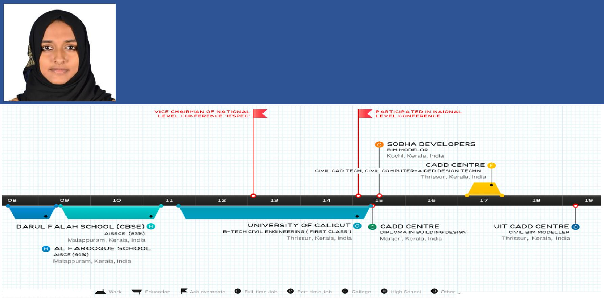
HUSNA

CIVIL ENGINEER / CIVIL BIM ENGINEER

Email: husna-395013@2freemail.com

SNAPSHOT

Professionally qualified in Civil Engineering and interior designing. Specialized in Project planning, Structural designing, Interior designing and Estimation using Inventory Softwares AutoCAD, Etabs, Revit structure and Revit Architecture.

Looking for career enriched opportunity in civil engineering, interior designing, structural designing and estimation with a frontline Organization of Repute.

COMPETENCIES & SKILL SETS

- Problem solving abilities
- Persuasive communicator
- Team Player
- Flexible and patience
- Social worker
- IEEE Member

- Delegated various organizing committees during academic tenure

- AutoCAD 3D
- Etabs
- Revit structure
- Revit Architecture
- Basics of 3dx max, Staad pro
- MS Office 2010/13/16
- Building estimation and costing (QT0)

PROFESSIONAL EXPERIENCE

Kerala, India (July 2017 – Oct 2017)

Designation: Interior Designer (intern)

- Preparing model of the planned structure using AutoCAD.

- Exporting the structure to REVIT Architecture and provides further changes in a 3D view.

- Interior Designing of the structure using REVIT, 3DX MAX under the directions of team leader.

- Estimation of cost using the software QTO under proper guidance of the team leader

Cochin (Aug 2015 - Nov 2015)

Designation: BIM MODELLER (Intern)

- Preparing BIM model of the planned constructions.

- Work under direction of design professionals and BIM Team leaders.

- Provide management and drawing/design skills in support of a detailed and accurate BIM model.

Page 1 of 2

- Produce shop drawings as per details given by engineer/manager.

- Develop engineer’s concept and sketches into accurate models and drawings.

- Drafting of Detailed structural drawings as per the instruction of the structural engineer.

- Implement any comments or revisions to drawings as required.

- Coordinating structural drawings with MEP and architectural drawings.

- Creating room legends, color schemes, monitoring sheets & correction.

- Assisting manager in work – Project wise uploading & Field change request updating works.

EDUCATION

- Bachelor Degree (BTech) in Civil Engineering, Thrissur, Calicut University. (2011-15)

- Masters in Building Design, CADD Centre

-AUTOCAD 3D

-REVIT ARCHITECTURE

-REVIT STRUCTURE

-ETABS

-BUILDING ESTIMATION AND COSTING (QTO)

ACADEMIC TRAINING

KM ELIAS CONSTRUCTIONS, Thrissur, Kerala, India (2013)

- Project - Shangri-la Apartments, Imperial Towers, Mughal Mall

ERNAD ENGINEERING ENTERPRICES, Malappuram, Kerala, India (2014)

- Project - Thayyikadavu Bridge (Govt. Project)

ACADEMIC PROJECT

Durability study on concrete using partial replacement of sea sand as fine aggregate

Emphasis on study of sea sand feasibility and replacing river sand with sea sand as fine aggregate in concrete. Checked strength and durability of concrete using various tests using GGBS as an admixture. Found good result in 60% replacement of river sand with sea sand. A New alternative for the fine aggregate - can overcome the scarcity of river sand and avoid excessive sand mining in India.

PROJECT

HOMESTEAD AQUA BAY PROJECT, Malappuram, Kerala, India

This project under HOMESTEAD epitomizes a unique combination of warm and unparalleled tradition with the grand luxury of the present located in the hearts of Malappuram, Kerala. Was a part of its interior and structural design using the inventory softwares of Autodesk.

SOBHA MALL, Thrissur, Kerala, India

A shopping mall in Sobha city, Thrissur built on 4.7 acres of land with a build-up area of more than 600,000 sq. feet, offering luxury business hotels, offices, restaurants etc. Worked under the team leaders in designing using AutoCAD.

PERSONAL DOSSIER

● DOB / Nationality / Marital Status |  | : | 30/11/1992, Indian, Married
● | Visa | : | Husband visa
● | Language Proficiency | : | English, Malayalam, Tamil, Arabic* (*Read & Write)
● | Interests | : | Blogging, Travelling, Reading.

REFERENCES

Page 2 of 2

