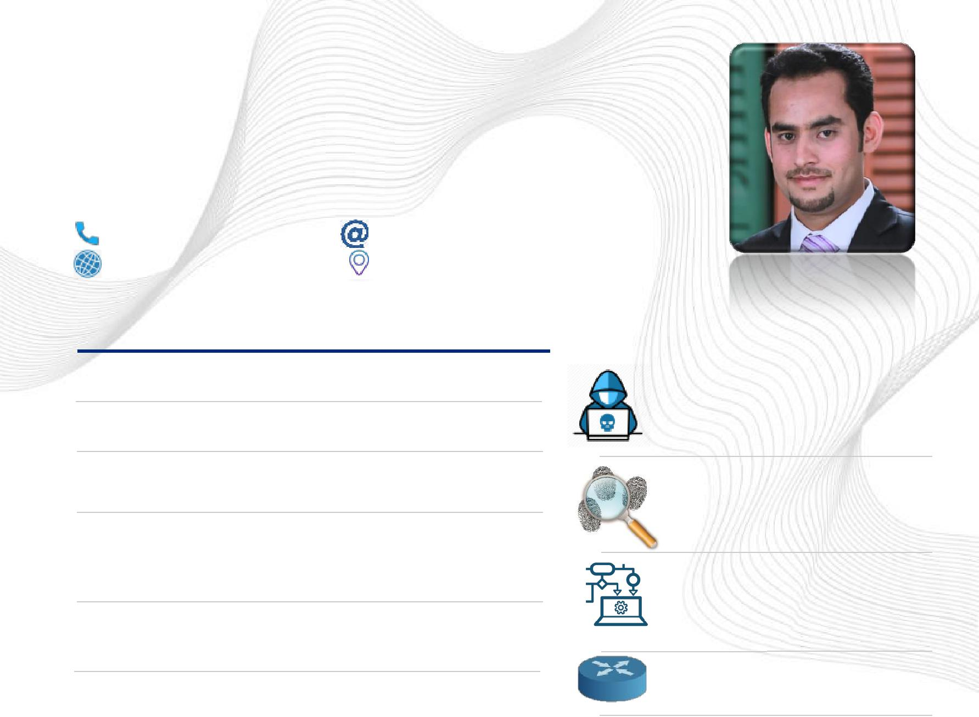
ZEESHAN

Network Architect | PEN Tester | IT Specialist

Zeeshan-395018@2freemail.com
United Arab Emirates

SUMMARY

7 Years of Experience in IT Field

A Certified Ethical Hacker from EC Council

Profound knowledge of Networking Security, Ethical Hacking, and Cyber Security

Collecting, organizing and manipulating large amounts of data using databases and other Technologies

Designing and implementing new network solutions and/or improving the efficiency of current networks

Installing, configuring and supporting network equipment including routers, proxy servers, switches, WAN accelerators, DNS & DHCP

Enjoying discovering and solving problems

Ability to communicate complex findings and ideas in plain language

TRAINING/COURSES

CEH Certified Ethical Hacker

EC Counsel ecc9106437582

CHFI
Computer Hacking Forensic Investigator

MCSA
Microsoft Certified Solutions Associate

CCNA
Cisco Certified Network Associate Routing & Switching

Security +
CompTIA Security+

CCA
Cloudera Certified Data Analyst

 | EDUCATION |  |  |  |  |  | AREA OF EXPERTISE
 | Masters (MS) in Cyber Security
 |  |  |  |  |  |  |  | Vulnerability Assessment & Management
 | Advanced Cryptography Digital Forensics |  |  | CGPA
 | Network Security Ethical Hacking Security |  | 3.38 / 4.0 |  |  |  |  | Information Security Management
 | in Cloud
 | 2017 - 2020
 |  |  |  |  |  |  |  | Cyber Forensics
 | BS Networking & Telecom BTN |  | CGPA
 | Telecommunication Network Management |  |  |  |  |  |  | Application Firewalls, SIEM, IDS/IPS
 | Mobile Communication Network Security |  | 3 | / 4.0
 | Network Designs , NOS
 |  |  |  |  |  |  |  | Machine Learning Tools and
 | 2012 - 2016
 |  |  |  |  |  |  |  | Techniques Computer Networking

Please Find Detailed Resume Below

Zeeshan

Email: zeeshan-395018@2freemail.com

Network Architect | PEN Tester | IT Specialist

Profile Summary

- A Certified Ethical Hacker from EC Council.
- 7 Years’ experience in IT Industry
- Profound knowledge of Networking Security, Ethical Hacking, and Cyber Security.

- Collecting, organizing and manipulating large amounts of data using databases and other technologies

- Designing and implementing new network solutions and/or improving the efficiency of current networks

- Installing, configuring and supporting network equipment including routers, proxy servers, switches, WAN accelerators, DNS and DHCP

- Enjoying discovering and solving problems
- Ability to communicate complex findings and ideas in plain language
Professional Certification & Knowledge

• | CEH | (Certified Ethical Hacker) (ecc9106437582) EC-Council Certified
• | CHFI | (Computer Hacking Forensic Investigator)
• | MCSA | (Microsoft Certified Solutions Associate)
• | CCNA | (Cisco Certified Network Associate Routing & Switching)
• | Security+ | (CompTIA Security+)
• | CCA | (Cloudera Certified Data Analyst)
Qualifications

- Masters (MS) in Cyber Security Majors : Advanced Cryptography , Digital Forensics , Network & Systems Security, Digital Content Analysis, Ethical Hacking, Security in Cloud Environment

- BS Networking & Telecommunication Majors : Telecommunication Network Management, Mobile Communication, Network Security Telecommunication , Network Design, Wireless Networks, Network Operating System

- DAE Electrical
Enterprise Application Software’s

- VMware VSphere (ESXi 5.5 client, vCenter servers, SAN / NAS storage management
- CAFM (Harmony PSA, FSI)
- Fortinet etc
- Palo Alto
- Cisco
- Juniper Networks etc

Professional Experience

(2010-2012)
Providing day-to-day support for office staff and equipment’s

Network Engineer COMSATS Abbottabad KPK (2016-2017)

Providing Network Support to clients as per their service contracts Secure new clients for network design/install upgrades

Accomplishments:
Implemented and managed new datacenter using clustered virtual servers.

Tested and implemented new network infrastructure throughout entire building
Managed and implement new client servers and infrastructure

IT Analyst at Islamabad Pakistan (2017-2018)
Managed the day-to-day running of office delivering first, second and third level support

Accomplishments:

Managed day-to-day operation across 3 sites in different location in Pakistan Maintain standard company infrastructure

Network Admin COMSATS Abbottabad KPK (2019-Now)
Taking necessary preventive action to ensure chronic info-security threats were not repeated.

Updating all departments on potential new cyber threats.
Conducting evaluation of intranets and firewalls on a regular basis.

Accomplishments:
Ensured risk reduction through information security policy development.
Employed various technical methods to safeguard customer data.
Designed network intrusion detection system and implemented supporting backup programs

Machine Learning (AI)

- ML Algorithms & Data mining, Text mining, Information retrieval Proficiency with Python and basic libraries for machine learning such as scikit-learn and pandas Theano, Tensorflow, Keras

- Expertise in visualizing and manipulating big datasets
Skills & Knowledge

- Network security with Snort, IDS, IPS, MOD SECURITY.
- Routing protocol (RIP, IGRP, EIGRP, and OSPF) STP, RSTP.
- Networking protocols (e.g., IPSEC, HSRP, BGP, OSPF,802.11, QoS)
- Security Standards: CCM, NIST CSF, ITIL, PCI-DSS , SIEM tools IDS/IPS, ISO27001 & GDPR
- Strong understanding of cloud (SAAS/IAAS) security requirements
- Strong knowledge on OWASP

- Administering & designing LANs, WANs internet/intranet DMZ and NAT-PAT & VoIP networks (PSTN, PBAX)

- VLAN, QoS, Active Directory, DNS / DHCP / LDAP / NFS Cisco Router, Cisco Switch, Switching (L2/L3), Network management Routers Firewalls

- Remote Access RDP, team viewer VNC, Telnet/SSH, HP ILO, iDRAC, PRTG & DELL KACE

- IP & IP Addressing, ACLS, sub netting TCP/IP ARP, ICMP,TCP, UDP, FTP, TFTP, MRTG, MRTG2 Nagios in Linux.

- OS: Any OS & NOS (Servers) including CentOS, Ubuntu , RedHat
- Languages: All most All Languages including C#, PHP, JavaScript , Python, R etc.
- Databases: SQL, MS-SQL, HBase etc.

Educational Qualifications

MS in Cyber Security (CUI ATD) CGPA 3.38 2017- - Majors
- Advanced Cryptography
- Digital Forensics
- Network and Systems Security
- Digital Content Analysis

- Ethical Hacking
- Security in Cloud Environment.

MS Research / Project Skills
- Topic: Automatic Analysis of Malware using Machine Learning.

- Contributing to team decisions about research directions.
- Data coding, data entry, data analysis & assistance with writing up.
- Excellent research skills.

- Able to plan research and organize tasks effectively.
- Ability to resolve problems independently.
- Possessing a creative approach to problem-solving.

- Expert in Writing Code, Scrubbing Data, Visuals for Presentations in Python and R Language.
- Topic: Automatic Analysis of Malware using Machine Learning.
- Contributing to team decisions about research directions.
- Data coding, data entry, data analysis & assistance with writing up.
- Excellent research skills.
- Able to plan research and organize tasks effectively.

- Ability to resolve problems independently.
- Possessing a creative approach to problem-solving.

- Expert in Writing Code, Scrubbing Data, Visuals for Presentations in Python and R Language.

BS in Telecommunication and Networking (COMSATS ATD) CGPA ≈ 3 2012-2016 Majors
- Telecommunication Network Management
- Mobile Communication
- Network Security
- Telecommunication Network Design

- Wireless Networks

- Network Operating System.

DAE (Electrical) 1st Division 2011
Majors
- Computer Application
- Application of Computer in Electrical Technology
- Telecommunication

SSC (Science) 1st Division 2008

Personal Information

DOB: 20 Oct 1991. Gender: Male.

Nationality: Pakistani. Passport & Driving License: Yes.

Marital Status: Married.

Visa Status: Visit

