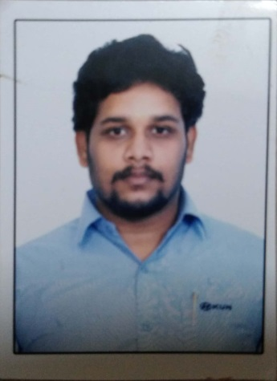

RESUME

Sarath
Mail: sarath-395022@2freemail.com

Summary of Qualification

- 10 Years of experience in service of automobile Four wheeler industry
- Well versed in all aspects of service – Internal workshop processes & quality feedback.
- Implemented improvement of service systems and quality for better customer satisfaction.
- Excellent training, leadership and communication skills.
- Hard working, able to multi-task effectively
- Proven ability in organizing service promotion activities & increasing service business.

Professional Experience

Joined as Front Office Service in-charge
SEP- 2016 – OCT -2019
CHENNAI -SHOLINGANALLUR JOB PROFILE:

- Achieve the Parts and Labour target set by the company. Resource utilization (Bay productivity, technician’s productivity and efficiency) housekeeping of the workshop.
- Developing short and long-term goals for each department manager (includes administrative, sales, parts, and auto body collision and service departments).
- Paying close attention to daily operations, recommending and creating improved courses of action where necessary.
- Coordinating regular meetings with the managers of each department to ensure their profitability and efficiency
- Maintaining an enthusiastic attitude to build positive employee attitudes and morale
- Focusing on any customer complaints that department managers are unable to rectify and taking the necessary steps to resolve these complaints.
- Dead stock liquidation
- Reviewing with the CRM on complaint closing and customer satisfaction on alternate day basis.

Professional Experience

Joined as a TEAM LEADER – SERVICE
for Service & Body shop
JULY- 2015 - AUG – 2016 (SHORT PERIOD) JOB PROFILE:

- To ensure the work undertaken by the workshop meets the commitments made to the customer in terms of quality, cost and timings.
- Interact with the Service Advisor and Quality inspectors to achieve highest levels of customer satisfaction.
- Provide an effective link between the workshop and front office to ensure that the needs of the customers are effectively understood by the Floor supervisors and Technicians.
- Manage the workshop scheduled to achieve smooth and efficient flow of work through the service department.
- Check the quality of all completed work providing guidance as needed to ensure that the quality standards are maintained.
- Monitor the repeat repairs and quality of work and initiate corrective actions
- Promote effective usage of workshop manuals and other literatures for diagnosis and quality of repair

Professional Experience

Joined as a Service Advisor & Promoted to Branch In-Charge
For Kattupakkam Workshop Service & Body shop
CHENNAI – PERUNGUDI
DEC- 2012 (TO) JUN-2015 JOB PROFILE:

- To ensure the work undertaken by the workshop meets the commitments made to the customer in terms of quality, cost and timings.
- Interact with Quality inspectors to achieve highest levels of customer satisfaction.
- Provide an effective link between the workshop and front office to ensure that the needs of the customers are effectively understood by the Floor supervisors and Technicians.
- Manage the workshop scheduled to achieve smooth and efficient flow of work through the service department.
- Check the quality of all completed work providing guidance as needed to ensure that the quality standards are maintained.

- Achieve the Parts and Labor target set by the company. Resource utilization (Bay productivity, technician’s productivity and efficiency) housekeeping of the workshop.

Joined as a Technician & Promoted to Floor Supervisor

AUTHORISED DEALER FOR CHEVROLET & TATA MOTORS
CHENNAI –EKKATUTHANGAL
JUN- 2008 (TO) NOV-2012

- Analysis of technical complaints of vehicle in the field.
- Diagnosing of technical complaints of vehicle in the field.
- Achieving monthly labour target.
- Responsible for spare parts target achievement in co-ordination with Spare Parts division.
- Inspection of failed components to give decision
- Network expansion- install adequate service facilities (additional service set-ups and bays)
- Responsible for starting the service facility.

Education & Personal details:

Status : Married

Age : 17.09.1989 (30 years old)

Language known : Tamil & English

Computer skill : Auto CAD-2000, Micro Soft Excel, Word, Power point,
Computer hardware

Elective Subject : Automobile

Visa type : visit visa (3month)

Qualification | Name of School/College | Year of Passing | Percentage
S.S.L.C | Kumararajamuthiahhr sec school | April 2004 | 81%
ITI –  Government of  Tamilnadu  Department  Of  Employment And Training Chennai  Course :  Mechanical  A/C Electrician  Automobile | BRILLIANT  INDUSTRIAL  SCHOOL CHENNAI | July -2008 | 85%

Regards,

Sarath

