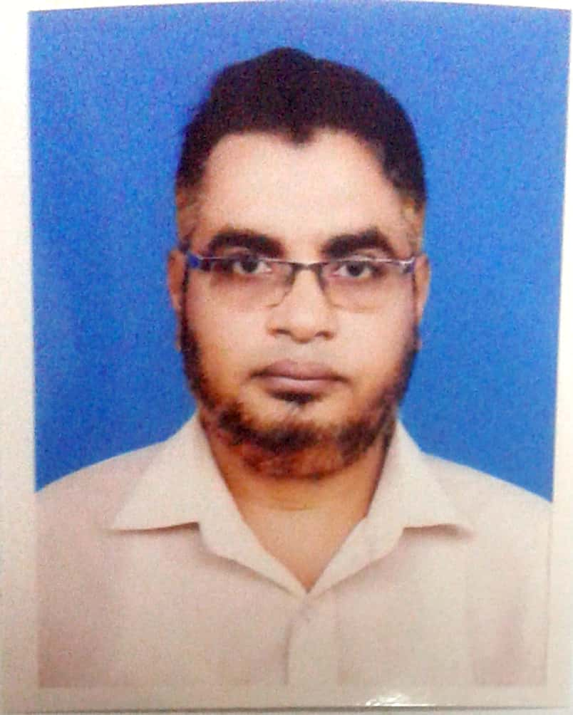

ZAHIDUL
Teacher of ICT and Computer Science
AREAS OF EXPERTISE |  | PERSONAL SUMMERY
- Revision lessons  - Pupils progress  - Behavior management  - Lesson Planning  - Marking worksheet  - Meeting presents  - Innovative pedagogical approaches  - Interactive Content Preparing  - Maintaining accurate formative and summative assessment records  - Critically analysis the progress and presenting graphically  - Arranging training for CPD  PROFESSIONAL  - Bengali & English Speaker  - First Aider  - Committed  - Coordination  PERSONAL SKILLS  - Determination  - Courage  - Friendship  - Excellence  - Inspiration  TECHNICAL SKILLS  - Recent Trends on ICT  - Data Communication and Networking  - Number System and Digital Devices  - Website Design and HTML  - Data Structure and Algorithm  - Programming in C  - Database Management System and SQL  GENERAL DUTIES  AND  RESPONSIBILITIES  - To manage the departments resources effectively  - To ensure appropriate value for money  - To ensure effective deployment of support staff within the classroom  ADDITIONAL DUTIES  - Working in such a way so that it’s possible to become a role model in all my actions and behavior  - To undertake professional development and research as agreed  - To be aware of and comply with policies and procedures relating to Child Protection and safeguarding, health and safety, and report all concerns to the appropriate person  - To take part in activities such as Open Evenings, Parents Evenings, Sports days, science and ICT clubs formation  CONTACT  ZAHIDUL  Zahidul-395028@2freemail.com  PERSONAL INFORMATION  - Date of birth  August 07 1979  - Marital status: Married  - Nationality : Bangladesh  - No. of dependents: 02  - Nationality of wife: Bangladeshi  - Qualification of Wife:  (4 Years Graduation Degree, B.D.S- Bachelor of Dental Surgeon- 10 Years Professional Experience as a Medical Office at Dental College & Hospital and 09 Years Private patients Practice as well)  - Nationality of Children:  Bangladeshi  - QTS Status  (4 Years Graduation degree in Computer Science and Engineering with Teachers Training Program )  - 1 Year scholarship program on networking from Bangladesh Computer Council  - 1 month teachers training program from Bangladesh Computer Council  - 1 Months from Rangpur Cantonment organized Army Education Core  - 19 days from Bangladesh Teachers Training Program  - 14 days CPD program from Teachers Training College and different in-house institutional short programs on creative questioning  VOLUNTEER EXPERIENCE  Since I grew up in a family where I saw my father working in various voluntary organizations for the sake of his employment and saw my mother as a government primary school teacher. As a result, my subconscious mind always wanted to see itself as an ideal teacher as well as a social worker. For this why I always like to work as volunteer on education field when I get chance out of my regular busy professional activities. And that’s why I finally founded an voluntary not for profit organization that is working for up lifting lives of the underprivileged children by providing STEM education in government primary schools as a non-formal education.  Name: Barefoot Social Development Organization  http://www.barefootbangladesh.org  ( Site is Under Construction not published yet)  Moto: Unlocking 21st Generations Future.  Platform: Both Online & Offline  - It is centre for educational research and innovation  - Working on Creating innovative learning environments  - It is focused on innovative ways of organizing learning for young people (ages 3-10) at the micro-level and on evidence of what makes the environments in which this takes place effective.  I argue that such focus should underpin the 21st century education reform agenda. |  | I believe that I’m an outstanding teacher of ICT and Computer Science, passionate about making a positive difference to the lives of 21st century generation and an energetic, versatile tutor who is able to teach across a wide range of Computer and ICT topics. I came to you with a strong background in planning lessons, organizing extra-curricular activities and helping to transform the lives of my pupils and making them with full of must have 21st skills and information for the “fourth industrial revolution”. I’m someone who possesses a variety of competencies that set me apart from other candidates. These are my abilities to not only get students to listen, but to also understand. As a seasoned professional I can turn best practices into high quality, goal-driven results. Aside from my technical competencies, my pleasant manner and excellent communication skills allow me to quickly connect with children from all social backgrounds.  At the moment I’m looking for a suitable position with an institution that has a culture that appreciates and rewards excellence and committed to shaping the future by providing a high quality, international education for its entire young people and from where I will get unique opportunities as well.  WORK EXPERIENCE  Rangpur, Bangladesh  [The District Police Super funded public school based on National Curriculum Text Book of Bangladesh offers a modern national approach to teaching and learning. The educational institution system is divided into stages based upon age early years foundation stage known as pre-primary education (ages 3–5); primary education (ages 5 to 10), secondary education (ages 11 to 16) and higher secondary education( ages 16 to 18)]  Lecturer (ICT) October 2015 – Present  Responsible for combining my professional experience and skills to teach a varied and ICT curriculum.  Reporting to: ICT Coordinator, Vice-Principal ( Academic), Vice-Principal( Administration) and Principal  Duties  To provide professional planning, teaching, assessment and monitoring within ICT and to work in partnership with the ICT Coordinator to develop the work of the institution in the following areas  - To teach ICT in a professional, dynamic and empathetic manner  - To Monitor and to develop strategies from the Stage primary to higher secondary stage of National Curriculum courses in ICT to all students including those who are Gifted and Talented and those with SEN (Students with Emergency Needs)  - To involve in initiatives actively that support the Mathematics and Computing Specialism including promoting the use of cross-curricular ICT and Primary, Secondary, Higher Secondary School collaboration  - To utilize innovative technologies to enhance learning and teaching  [[ Actively involved in curriculum review and development  - To ensure that schemes of work are properly planned and delivered Ensure effective curriculum coverage continuity and progression in the subject  - To use the subject taught to prepare students for the opportunities, responsibilities and experiences of adult lives  - To input data into the School Information Management System (SIMS) for use in assessment Learning and Teaching  Dhaka, Bangladesh  [One of the private Universities of Bangladesh offers a modern international approach to teaching and learning. The educational institution system is divided into graduation ( ages 18 to 22) and post-graduation ( ages 22+)  Asst. Soft. Eng cum Lecturer (CSE) September 2007 – September 2015  Responsible for Upgrading database management system and strategic assistance for distributing the database facilities through network.  Reporting to: Deputy Exam Controller and Exam Controller  Duties  - To monitor regularly, assess and evaluate faculty-wise student progress  - Reporting to exam controller through the University Management Information System (UMIS) in a structured systematic way and  - Keeping appropriate records online and offline on a regular basis as database information backup  Cantonment Public School and College – Rangpur, Bangladesh  [The Cantonment funded public school based on National Curriculum Text Book of Bangladesh offers a modern national approach to teaching and learning. The educational institution system is divided into stages based upon age early years foundation stage known as pre-primary education (ages 3–5); primary education (ages 5 to 10), secondary education (ages 11 to 16) and higher secondary education( ages 16 to 18)]  Lecturer (ICT) July 2006 – August 2007  Reporting to: Vice Principal, Principal and College Coordinator.  Responsible for preparing strategic direction to regularly monitor, assess and evaluate student progress within own teaching groups in a structured systematic way and keep appropriate records.  Duties  - To work with the vice-principal (academic & administration) to use value added and other forms of data to compare the performance of different teaching groups within the department  - To work with the vice-principal to provide appropriate analysis of student outcomes and departmental performance for the Leadership team and Governors Standards and Quality  - Assurance Support the aims and ethos of the institution  - To follow institution policies and procedures  - To set a good example in terms of dress, punctuality and attendance  - To attend and participate in open evenings and report on pupil progress  - To uphold the schools behavior code and uniform regulations  - To participate and contribute to staff training  - To attend team and staff meetings called by the authority  - To embrace positively professional development and research  - To reflect on and improve performance  Dinajpur, Bangladesh  [The Defense ministry funded public school based on National Curriculum Text Book of Bangladesh offers a modern national approach to teaching and learning. The educational institution system is divided into stages based upon age early years foundation stage known as pre-primary education (ages 3–5); primary education (ages 5 to 10), secondary education (ages 11 to 16]  Assistant teacher (Computer Studies) May 2005 – June 2006  Responsible for conducting Computer Study classes and full-filling aim and objectives of the subject.  Duties  - To demonstrate high standards and enthusiasm of teaching in the role of an IT teacher  - To ensure that teaching meets the needs of all students, including the effective management of behavior  - To use ICT technologies effectively in the delivery of teaching and learning  - To ensure the development of students ICT, literacy and numeracy skills through the subject where relevant  Ladybird English Medium School – Kholahati, Dinajpur cantonment, Bangladesh  [The Cantonment funded international autonomous school offers a modern international approach (National Curriculum of England and Wales). to teaching and learning. The majority of the students are local army personnel’s children but there are about 30% expat students. The educational institution system is divided into stages based upon age early years foundation stage (ages 3–5); primary education (ages 5 to 11), subdivided into Key Stage 1 (KS1) Infants (ages 5 to 7) and Key Stage 2 (KS2) Juniors (ages 7 to 11); secondary education (ages 11 to 16), subdivided into Key Stage 3 (KS3; ages 11 to 14) and Key Stage 4 (KS4) ages (14 to 16)]  Assistant teacher (Computer Science) January 2003 – April 2005  - To work with the Principal in using data effectively to identify students who are underachieving in the subject and create plans of action with target setting at key points in the year  - To implement policies and practices for the subject that reflect whole school aims and objectives  - To maintain a climate which enables other staff at the institution to develop and maintain positive attitudes towards the subject  - To attend Curriculum Area and other meetings relevant to the post as required  - To prepare Records of Achievement and Experience for students  - To plan, teach, assess and monitor across Key Stage 1 and 2 to the highest standards  - To use the outcomes of self-evaluation to set the strategic direction and create an appropriate teaching plan  - Establish a partnership with parents to involve them in the Childs learning and promote effective links with the local community  - To ensure appropriate risk assessments are carried out as mentioned in the ICT Policy of the institution for class activities  ACADEMIC QUALIFICATIONS  Ahsanullah University of Science and Technology 1998 – 2002  BSc Computer Science and Engineering (CGPA 3.03 out of 4)  Carmichael College Passed 1996  Higher Secondary Certificate Examination Rajshahi Board  Group: Science with first Division  Rangpur Zilla School Passed 1994  Secondary School Certificate Examination Rajshahi Board  Group: Science with first Division  Major Subjects  (A) Bangla (B) English (C) Mathematics (General & Higher) (D) Science (Physics, Chemistry & Biology) (E) Information and Communication Technology.

