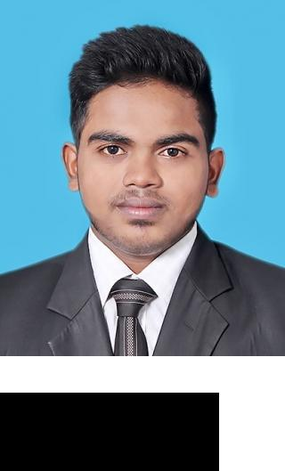

PERSONAL STATEMENT

WORK

EXPERIENCE

Ashik

E-mail: ashik-395049@2freemail.com

I'm 22 Years old where i seek an progressive organization, I have gained the ability to express my own initiatives & i am willing take further training to enhance my existing skills & gain more techniques with good timekeeping, proven problem solver & team-player with flexibility & extremely trustworthy, i would like to work under pressure using my own initiative, aggressive.

Jan 2017 — Aug 2019

Automotive Service Advisor

Duties & Responsibilities:

Greet customers & Scheduling service appointment.

Maintains vehicle records by recording service and repairs.

Provide customers with solid solution.

Distributing customer vehicles to service section.

Verifies vehicle serviceability by conducting test drives; adjusting controls and systems.
Keeps supplies ready by inventorying stock; placing orders; verifying receipt.

Accomplishes maintenance and organization mission by completing related results as needed.
Contains costs by using warranty; evaluating service and parts options.

Updates job knowledge by participating in educational opportunities; reading technical publications.

Jan 2017 — Jan 2019

Automotive Maintenance Technician

Duties & Responsibilities:

Perform routine automotive maintenance tasks, including oil changes, tire rotations, transmission flushes, air conditioner re-charges, front-end alignments, battery installations and headlight/taillight installations.
Maintain a working knowledge of current industry best practices in automotive repair.

Conduct extensive diagnostic procedures to determine the sources of customers' problems and provide accurate repair recommendations.
Conduct necessary repairs and take vehicles for test drives to verify soundness.

Maintain legible and accurate paperwork for both the customer and for our records. Clean and maintain the work environment to ensure equipment longevity and workplace safety.

Jun 2016 — Dec 2016

Trainer

Perform simple Automotive repairs.

Help keep repair shop clean & organized.

Learn repair techniques.

1

EDUCATION

KEY SKILLS

REFERENCES

PERSONAL INFORMATION

Follow Car checklist.

Willingness to learn with hands-on training.

Plan repair procedures using charts manuals or Head Technician advise.

Test the functionality of parts and system.

Inspect and test vehicles.

Disassemble vehicle and engines.

Automobile Engineer

FLITS (PVT) LTD

CITY & GUILDS ADVANCE HYBRID SYSTEM (LEVEL 2 & 3)

FLITS Vocational Training Institute Complete.

CITY & GUILDS AUTOMOBILE ENGINEER IVQ (LEVEL 3 & 5) DIPLOMA FLITS Vocational Training Institute Complete.

INTERNATIONAL AIRLINE TICKETING ACADEMY

Followed Diploma in Airline Fares / E - Ticketing, Reservations, Marketing, GDS, Tours, Airport Operation & Cargo conducted by Mr. Deepal Perera at International Airline Ticketing Academy. (Complete)

CHILAW INTERNATIONAL SCHOOL

IGCSE Cambridge & G.C.E Ordinary level Passed 2014.

Self motivated & hard working.

Flexible, creative, dynamic.

Ability to pick up new skills.

Computer Proficiency

Hardware & Platform: Win 7 upward.

MS Office.

Maintain Data entry records.

Date of Birth | : 1997/06/23.
Nationality | : Sri Lanka (Malay).
Visa Status | : Visit Visa (Valid till 05/01/2020).

2

