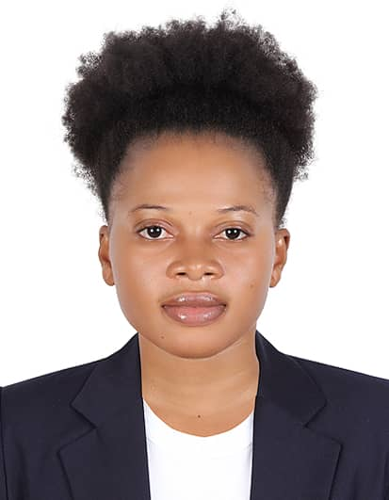
CURRICULUM VITAE

Personal details
Names : Mariam
Nationality : Nigerian
Marital Status : Single
Visa : Visit Visa
Email : mariam-395057@gulfjobseeker.com

CAREER SUMMARY
Seeking a position with an organisation, which will allow me to contribute my skilltowards the achievement of my employer’sgoals, while enabling me to learn and grow within the company.

PERSONAL
Communication
Willing to serve others
Polite and friendly
Clean and neat
Team player
Healthy and fit
Able to thrive under pressure
Flexible in working patterns

LANGUAGES
English
Yoruba

INTERESTS
Cooking
Outdoor Sports
Environmental Conservation

WorK Experience
Office assistance
2012/2013

Office/Administrative Assistant role.
Demonstrated capacity to provide comprehensive support for senior-level staff, including managing and coordinating projects and processes in support of effective business operations.
Proven track record of accurately maintaining detailed records, generating reports, coordinating meetings, and multitasking within fast-paced atmospheres.
Adept at managing and streamlining administrative processes to reduce errors, improve accuracy and efficiency, and achieve organizational objectives.
Outstanding interpersonal, customer service, leadership, and organizational skills; thrive within detail-oriented, deadline-driven environments.

Education

2009-2012 Government Science and Technology
- Technical School Certificate

2001-2006 Makun High School
- Senior Secondary School Certificate

1995-2000 UAMC eleja Primary School
- First School Leaving Certificate

PROFESSIONAL QUALIFICATION

2013 Catering and Hotel Management

Training

2015 – National Driving License

REFEREES
UP ON REQUEST

