CONTACT

Email

Sunu-395058@2freemail.com

LinkedIn

Location

Dubai, UAE

PROFESSIONAL SKILLS
- AutoCAD (2D, 3D)

- ArchiCAD

- Revit

- Barcad (RC)

- BS 8666:2005

- AISC Standard

- IS Coad

- MS Office

- MS Excel

SUNU
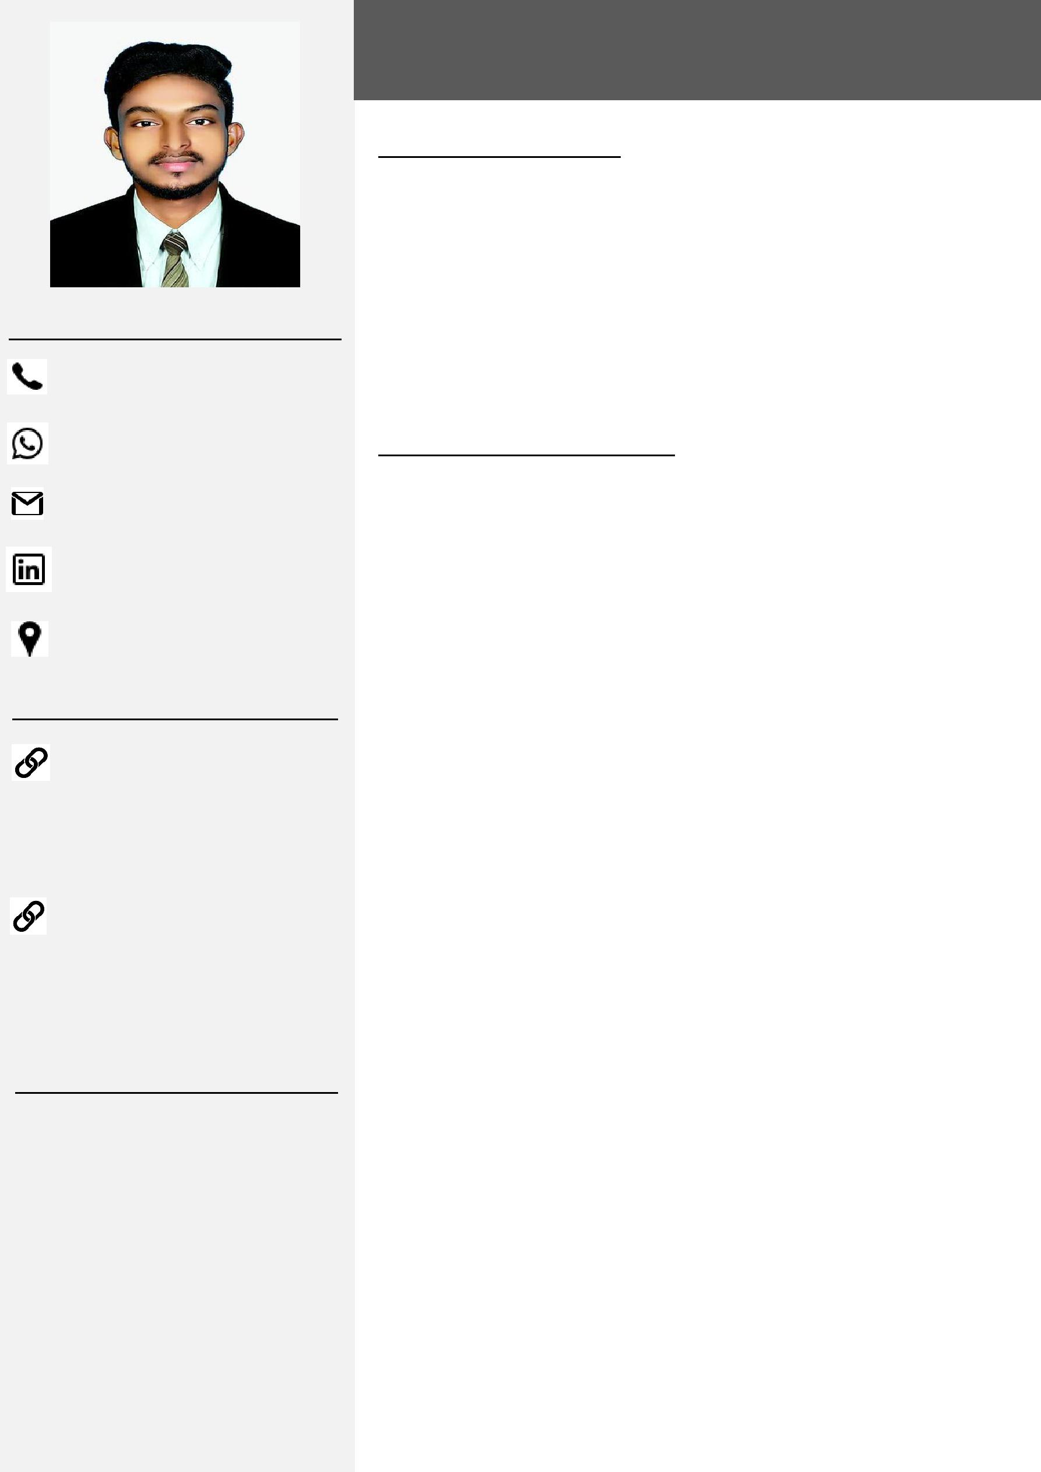

Structural / Architectural Draughtsman

PROFESSIONAL PROFILE

- 3.5 + years of experience in Structural, Architectural Drafting and Detailing.

- Proficient in structural shop drawings preparation for RC, Steel structures.

- Proficient on variety of Infrastructural and Building projects.

- Proficient in AutoCAD (2D, 3D), Revit and International building codes; BS 8666: 2005, IS, AISC Standard.

PROFESSIONAL EXPERIENCES

Structural Draughtsman and Detailer (RC) Dec 2017 to Apr 2019

Trivandrum, Kerala, India.

Key Responsibilities:

- Preparation of RC shop drawings with respect to the approved GA / IFC drawings, for various Substructure & Superstructure components by Using AutoCAD and BS 8666: 2005 Standard.

- Preparation of General arrangement plan for Pile Caps, Portal Beams, Pier Caps and Bridge span segments etc.

- Preparation of Bar Bending Schedule (BBS).

- Drafting plans from scratch, client sketches or other documentation sources, per AutoCAD standards (Layer management, plot styles, ctb’s etc.)

- Tagging and annotating plans by Using Revit Structural.

- Following up on RFIs issued to customers pertaining to drawing changes and revision.

Major Projects Handled:

- Extension of Dubai Metro Route 2020 (Portal Beam & Pier caps), Dubai, UAE.

Clients: Parson Systra & Expolink Consortium (Acciona, Gulermak, Alstom)

- Al Bustan Street North B6-B8 (Precast Segmental Deck), Qatar. Clients: VSL Middle East LLC, Qatar.

- Sobha Creek Vista G+2P+28+Roof Apartments, Al Merkadh, Dubai, UAE.

Clients: PNC Architects, PNC Investment LLC.UAE & MD Trading LLC.

Dubai, UAE.

ACHIEVEMENTS

- Autodesk Certified Professional in AutoCAD

- Site Engineer Trainee at

Kochin Metro Rail Projects, Kochin, Kerala, India.

- Attended Auto CAD Civil 3D practical training program at

MD Info System Pvt. Ltd, New Delhi, India.

PERSONAL INFORMATIONS

Age |  | : 24 Years
Date of Birth |  | : 08-09-1995
Sex |  | : Male
Nationality |  | : Indian
Marital Status |  | : Single
Passport Details
Date of Issue |  | : 25-11-2015
Date of Expiry |  | : 24-11-2025
Place of Issue |  | : Trivandrum
Visa status |  | : Visiting Visa

(Valid till 28-01-2020)

LANGUAGES KNOWN
- English

- Malayalam

- Hindi

- Tamil

INTRESTS

- Travelling

- Music

- Browsing

- QENBFB Infrastructural. & Utility Building for New Naval Base

Project State of Qatar.

Clients: Worley Parson Recourses & Energy, MSF Engenharia JV

JV.QMJV.

- UPC - Al Rayyan Project (Precast Manhole), Qatar. Clients: United Precast Concrete Company. W.L.L (Qatar)

Architectural Draughtsman Sep 2015 to Nov 2017

Amithasreelakshmi Builders & Designers (P) Ltd, Bangalore, India.

Key Responsibilities:

- Preparation & presentation of statutory and working drawings for architectural plans by using AutoCAD.

- Preparation of working drawings shown plans, elevations, sections, finishes and other details.

- Preparation of Architectural Drawings for BBMP law approval.

- Prepare the multiple versions of design for review by engineers & architects.

- Preparation of “As Built” Drawings from the marked up copies of construction drawings.

- Creating sections, details and typical details.

Major Projects Handled:

- Raindrops Residential Project at Chikkanyakanahalli, Bangalore, India.

Clients: Punarjani Properties Pvt.ltd, Bangalore, India.

- Confident Hercules 5 storey Apartment Project at HSR Layout, Bangalore, India.

Clients: Confident Group, Bangalore, India.

TECHNICAL QUALIFICATIONS

➢ Diploma In Civil Engineering |  | 2013 to 2015

From Institution of Civil Engineers (India) - New Delhi, India. (Director Technical Education Board - New Delhi, India). GPA – 70 %
➢ Diploma in AutoCAD |  | Sep 2015

From CADD Centre Training Services, Kollam, Kerala, India.

DECLARATION

I hereby declare that all the details furnished above are true to the best of my knowledge and belief.

Place: Dubai, UAE.

Date: 01/11/2019 SUNU

