CURRICULUM VITAE

SATHIYA
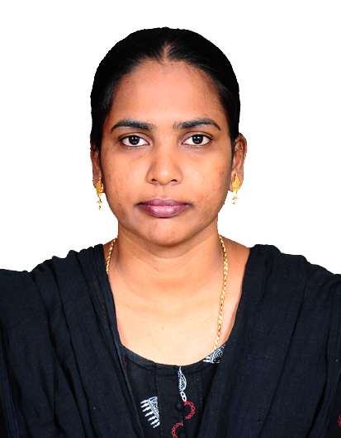
E-mail : sathiya-395064@gulfjobseeker.com

CAREER OBJECTIVE:

- Creative, resourceful Teacher with Eight years of varied instructional experience.
- Possesses an effective, positive and flexible teaching style with the willingness to work beyond the call of duty.
- To encourage creativity and higher - order thinking in a way that increases student performance.
- To obtain a position as an elementary school teacher that will utilize my dedication to Children's educational needs and development.
- Qualified Elementary School Teacher with proven ability to enhance students performance.

SUMMARY OF SKILLS:

- Demonstrated sound work ethics.
- Self-motivation, initiative with high level of energy.
- Able to inspire, comfort, build self-esteem.
- Excellent communication skill.
- Ability to listen to children and parents.
- Knowledge of developmental theory and corresponding practice of education.
- Stress and time Management ability.

PERSONAL EXPERIENCES:

PRIMARY TEACHER
- Nursery and Primary School, Vellore (2003 - 2004)
- Nursery Primary School, Vellore (2013-2014)
- Higher Secondary School, Vellore (2014 - 2019)

EFFECTIVE ON:

- Instruct over 50 primary school aged children in activities designed to promote cognitive, physical and Social development.
- Maintain daily classroom schedule, which includes learning English, Maths, Science, Social Science.
- Created “Children on the bus” a 15-minute session which combines dramatic play and learning through music and singing.
- Designed and use ‘hands-on-learning’ Centre for Science, Social Studies, Language development and health
- Created poster board story time, “where children participate in story telling bye verbally and artistically creating their own story endings.
ARTISTIC ACHIEVEMENTS:

- Develop art projects for holidays and learning units, including leaf painting for fall and rainy day collages for the weather.
- Create seasonal artwork for hallway and display bulletin boards.
- Co-ordinate and design artwork and scenery for annual “Spring Graduation Program”.
- Serve as Creative Consultant for Multicultural celebrations.

EDUCATION:

- M.A. (Master of Arts in English) in Annamalai University, Chidambaram – 2012
- B.Ed., (Bachelor of Education in English) in NDM College, Vellore – 2015
- B.A., (Bachelor of Arts in English) in Annamalai University, Chidambaram – 2005
- D.T. Ed., Diploma in Teacher Education) in Bharath College, Vellore – 2012
- HSC in Bharath Matric. Higher Secondary School, Kosapet, Vellore - 2001
- SSLC in Bharath Matric. Higher Secondary School, Kosapet, Vellore – 1999
SPECIAL SKILLS:

- Distinction in Office Automation (MS Office); 2004
- First class in Typewriting Higher Grade in English; 2004
- Certificate of merit in English skills for Teachers; 2019
- Good interpersonal skills.
PERSONAL DETAILS:

Date of Birth : 21-12-1982
Marital Status : Destitute Widow
Nationality : Indian

DECLARATION:

I shall strive sincerely for the wellbeing of your concern if given me an opportunity to work in esteemed Organization. All the above true to my best of knowledge and belief.

Place: Dubai (UAE)
Signature of the Candidate

