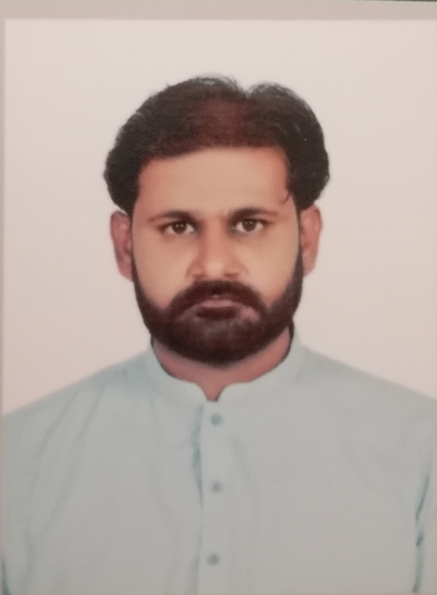

Toqeer
Address: UAE
Email: toqeer-395067@gulfjobseeker.com

Career Objective:

I would like to work in a dynamic organization that supports the application of analytical and technical skills to improve the company’s profitability and provides an opportunity for professional efficiency and growth.

Academic Qualification:

- BBA (Hons) Al-Khair University A.J.K (2006-2010)
- Diploma in Business Administration P.B.T.E Lahore (2005)
- SSC from BISE Sargodha (2003)

Additional Qualification:

1 Year Diploma in Computer Hardware & Software

Professional Experience:

August 2016 to September 2019
Parent Relations Officer
Duties:
- Admission Confirmation- Successful conversion of all new visitors into admissions by continuous follow up and updating the same in BEAMS
- Withdrawal Retention- Ensuring 100% effort in retention of all withdrawal requests for all those cases where Management decision or input is required
- Maintenance of Student Record- Ensuring that the student personal file and Beams record is properly updated and maintained
- Follow up Calls to all the fee defaulters - Ensuring maximum recoveries and hence zero or minimum auto-withdrawals.
- PRO Contact Validation- ensuring that the contact with the parents is validated on regular basis as per the described formula.
- Monitoring Student Attendance- Ensuring 100% student attendance marking on BEAMS

September 2015 to May 2016
HR Officer
Duties:

- Support the development and implementation of HR initiatives and systems
- Provide counseling on policies and procedures
- Be actively involved in recruitment by preparing job descriptions, posting ads and managing the hiring process
- Create and implement effective onboarding plans
- Assist in performance management processes
- Support the management of disciplinary and grievance issues
- Maintain employee records (attendance etc.) according to policy and legal requirements
- Review employment and working conditions to ensure legal compliance

November 2014 to September 2015
Accountant:
Duties:

- Prepares asset, liability, and capital account entries by compiling and analyzing account information.
- Documents financial transactions by entering account information.
- Substantiates financial transactions by auditing documents.
- Reconciles financial discrepancies by collecting and analyzing account information.
- Secures financial information by completing data base backups.
- Maintains financial security by following internal controls.
- Prepares payments by verifying documentation, and requesting disbursements.
- Answers accounting procedure questions by researching and interpreting accounting policy and regulations.
- Complies with federal, state, and local financial legal requirements by studying existing and new legislation, enforcing adherence to requirements.
- Prepares special financial reports by collecting, analyzing, and summarizing account information and trends.
- Accomplishes the result by performing the duty.
- Contributes to team effort by accomplishing related results as needed.

September 2010 to June 2014
Mazmoon-i-Shauq School:Administrator:
Duties:

- Financial Management. Maintaining a database of all accounts, updatingall receivables and payables.
- Office Management, providing technical support to the staff and students.
- Conducting Banking transactions
- Word processing
- Scheduling and coordinating appointments and events.
- Maintaining student’s files, preparing exam papers and reports.

July 07, 2010 to 26th November 2010:
College of Global Technologies Rawalpindi:Coordinator:
Duties:

- Coordinating instructions with head office for timely completion of work plan
- Implementation of policy and procedures and updating daily data
- Evaluation of instructional program
- Facilitating and organizing interviews for various positions
- Preparation and maintenance of students files
- Preparation of admission/registration and examination forms
- Reporting to head office
- Coordinating/implementing policies/instructions to other branch offices in Islamabad, Swat and D.I.Khan.
- Implementing policies for examinations

Jan 4, 2010 to July 02, 2010
Beacon Abroad System Rawalpindi:(Foreign Education Consultancy)
Marketing Executive:
Duties:

- Networking with clients, partners and public
- Communicating and Managing client’s relationship
- Sourcing, advertising (newspapers, radio, T.V)
- Managing marketing materials, including leaflets, posters, newsletters, brochures, & Cd’s
- Arranging for the effective distribution of marketing materials
- Maintaining and updating client’s databases
- Organizing and promoting conferences, seminars, exhibitions etc.
- Managing the budget
- Evaluating marketing complaints

September 24, 2007 to October 31, 2008:
Dewan Salman Fibre Ltd (Group of Industries) Hattar Haripur
- Supervisor (Human Resource Department):
Duties:

- Preparing monthly salary
- Analyzing reports for all Dewan Salman Fibre Ltd locations
- Preparing monthly staff turnover report for all locations
- Preparing salaries for daily wage earners
- Maintaining Staff files on regular basis
- Preparing final settlement of employees. (Induction day, casual/sick leave)
- Computerizing employees work history
- Implementing Employees Old-age Benefit Insurance & Employees Social Security Insurance policies

- In charge Time Office: Dewan Salman Fibre Ltd (Group of Industries) Hattar Haripur

Duties:
- Maintaining employees working hours
- Preparing monthly attendance data and payroll
- Preparing monthly roster for smooth operation of four shifts
- Preparing daily attendance & summary report

Interpersonal Skills:

- Proficient in Communication and Organization
- Sharp Administrative & Management Skills
- Hardworking, trustworthy and energetic
- Creative ability with an analytical mind especially in understanding business processes
- Ability to work as team player
- Reporting & presentation skills
- Able to produce productive and quality work even when multi-tasking

References:

Will be provided on request

