 |  | SHEBA
 |  | Emai: sheba-395076@2freemail.com
CAREER | To be able to utilise the knowledge gained, in a responsible and proper manner resulting in a value add
OBJECTIVE | to the organisation and to reach the apex of my career in the process.
EDUCATION | Mar Athanasious College for Advanced Studies,Tiruvalla.
 | M.B.A( HR-OPERATIONS)
 | Results Awaiting
 | 2016-2018
 | Our International Institute,Abu Dhabi,U.A.E
 | Bachelor of Commerce with Computer Application
 | 57.75
 | 2015
 | St.Mary's Public School , CBSE, New Delhi
 | Senior Secondary
 | 54.20
 | 2012
 | St.Mary's Public School , CBSE, New Delhi
 | Higher Secondary
 | 7.8
 | 2010
EXPERIENCE | in Ernakulam, Kerala | 1st March 2018 - 10th January 2019
 | Sr.HR Executive
 | Management of day to day administration.
 | Planning,scheduling and organizing of meetings and appointments
 | Creating and maintaining of employee information into database.
 | Maintaining HR records.
 | Reviewing resumes and applications
 | Conducting recruitment interviews.
 | Preparation of Salary Statements.
 | Grievance handling.
 | Recording, maintaining and monitoring employee activities.
 | In Abu Dhabi, U.A.E | December 2014 - March 2015
 | Front Oﬃce Operations
 | Application assistance,recording of biographic and biometric enrollment, verification and
 | authentication,recording,processing and management of documents and passports
 | Vibes Event Management | 20 January 2014 - 13 September 2014
 | Customer Relation Executive
 | Registration assistance and customer relations.
 | Competency Mapping of Employees,ICMS International. | 8th January- 3rd March,2018.(2 months)
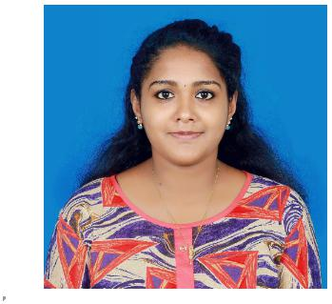
PROJECTS | Study and analysis of the competency level of each employees and its influence on the functioning of
 | the organisations growth and development.
PERSONAL | Adaptable, Quick Learner
STRENGTHS

PERSONAL | Date of Birth | : 07 September 1994
PROFILE | Marital Status | : Married
 | Nationality | : Indian
 | Known Languages | : English,Hindi, Malayalam
 | Hobby | : Drawing,Crafting And Quilling.

SHEBA

