SWAGATA

OBJECTIVE
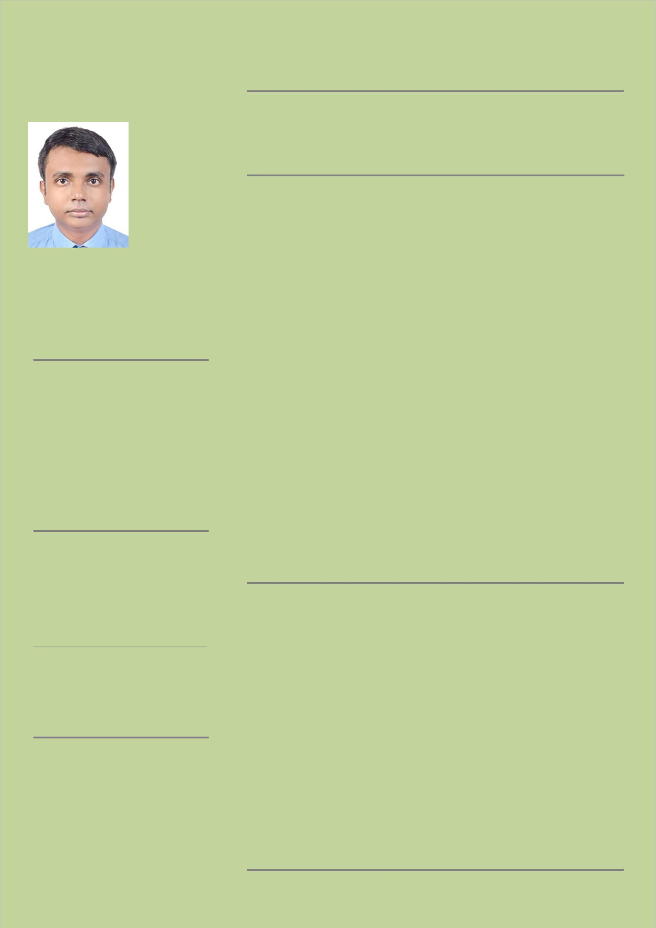

A proactive professional with expertise in delivering technical solutions, and facilitating software improvements &upgrades, seeking an opportunity to work for the growth of the organization.

WORK EXPERIENCE

10/2016 – Till Now

Head Of Business in Kolkata , India

Responsibilities:
- Establish operation strategy in a team for improving sales.

- Prepare data and information for making regular report data analysis.

- Liaising with superior to make decisions for operational activities and set strategic goals.

- Handled IT operations.

CONTACT

Email:

Swagata-395077@2freemail.com

LANGUAGES

ENGLISH

BENGALI

HINDI

EDUCATION

Bachelor Degree of Computer Science & Engineering , West Bengal University of Technology(2007-2011)

CERTIFICATION

Oracle 9i Certified Associate-DEV from HCL Career Development Centre in 2010.

Vacation Training from Steel Authority of India Limited in 2010

Project Based Training from CMC academy in 2010

03/2012 – 09/2016

Assistant Manager (I.T.) in Kolkata, India

Responsibilities:
- Oversaw the functioning of the organization's IT department.

- Handled IT operations.

- Actively involved in the planning, monitoring, implementation, and control of the testing activities.

- Organized repair for hardware issues.

- Scheduled the tests for execution.

- Installed and configured computer hardware and software.

- Planning and monitoring the day to day running of business to ensure smooth process.

- Supervising staff from different s and provide constructive feedback.

SKILLS

- SLA Management

- Capacity Planning

- Performance Analysis

- Knowledge Of Windows, Server, Linux, Networking , Cyber Security

- Database Management

- Incident Management

- Digital Marketing

- Infrastructure Management

- Disaster Recovery Implementation

- Prepare Technical/ Functional Documentation, Troubleshooting

- Time Management.

- Communication

- Adept New Technology

- Data Analyst

- Business Relationship Manager

- Basic Knowledge of google analytics

REFERENCES

References available on request

