PERSONAL DETAILS

Sex: Male

Marital Status: Single

Email: simson-395123@2freemail.com

Date of Birth:16/01/1990

Languages: English, Hindi &

Malayalam

With UAE Driving License

Visa Status: Resident Visa

HOBBIES

Gardening

Travelling

Photography

SIMSON
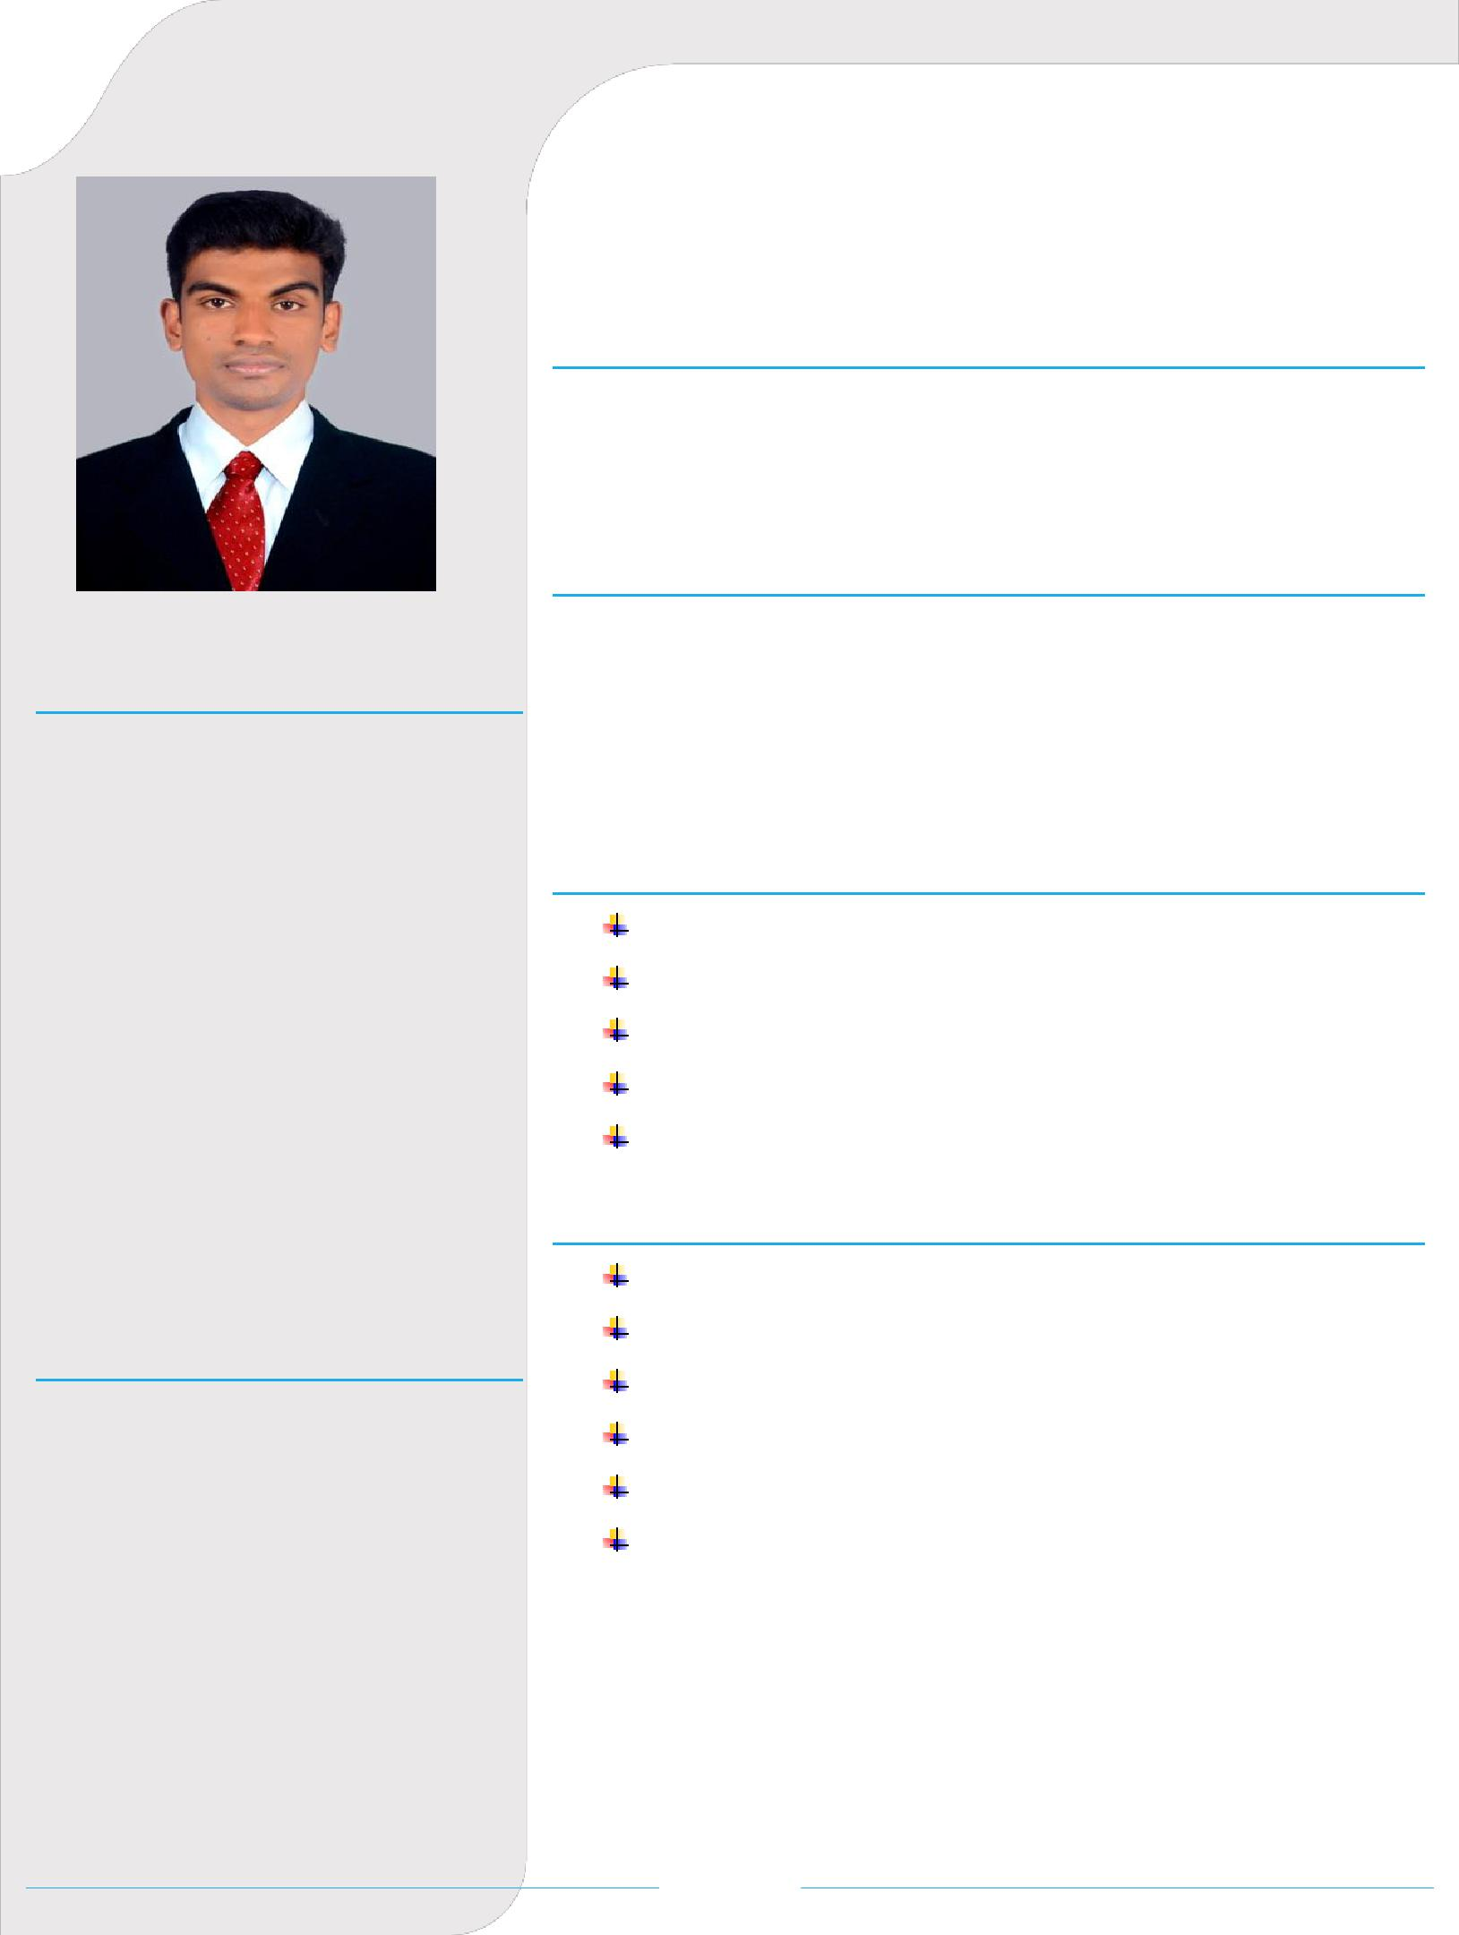
HR PROFFESSIONAL

CAREER OBJECTIVE

A Result-oriented Professional with 7 years of extensive experience in the field of HR & Administration. I prefer to work in an organization where I can utilize my professional skills to achieve the overall objective of the organization.

EDUCATION

Master Degree (Bangalore University)

MBA – HR & Marketing (Karnataka, India).

Bachelor’s Degree (Kerala University)

BSc Hotel Management & Catering Science (Kerala, India).

AREA OF EXPERTISE

Recruitment Cycle

Employee Relations

Performance Appraisal

Payroll Processing

Leave Management

CORE COMPETENCY

Team Work

Flexible & Adaptable

Result oriented

Training & Development

Loyal

Time management

Page 1

WORK HISTORY

1. Company Name : International Catering

Designation : HR Officer

Industry

: Catering & Hospitality

Work Period

: 13/11/2017-Till date

Reporting To

: Head-HR & Administration

- Company Name : M/s RDS Project Ltd. Kerala, India.

Designation

: Officer - HR and Administration.

Industry

: Construction/ Infrastructure

Work Period

: 12/06/2013 – 29/09/2017

Reporting To

: General Manager

3. Company Name : Hotel Presidency. Kerala. India.

Designation : HR- Trainee

Industry Work Period Reporting To

: Hotel/Hospitality

: 05/12/2012 to 31/05/2013.

: HR Manager

JOB PROFILE

Managing the recruitment cycle for sourcing the best talent from diverse sources after identification of manpower requirement for new/existing department.

Carrying out induction / orientation program to the new recruits.

Facilitating newcomers joining formalities.

Responsible of applying/cancelling insurance cards of employees.

Completing probationary period appraisal for the newly joined employees and ensure job confirmation is issued based on evaluation done by their respective line managers.

Maintaining and regularly updating database (personal file, database, etc.) of each employee.

Monitoring attendance, absenteeism, sick leaves to ensure employee punctuality.

Expertise in handling payroll management and ensuring timely dispersal.

Preparing relevant letters/documents/certificates as per the requirement of employees in consultation with the management.

Page 2

Monitor and ensure the timely processing & renewal of VISA & medical card etc.

Preparation of annual leave plan and air ticket booking.

Preparation of End of Service and ensuring timely dispersal.

Piloting performance appraisal of employees and promotion planning.

Conducting Employee satisfaction surveys and taking corrective action to retain the satisfaction.

Handling employee grievances and counselling them to keep up high morale in the organization.

Conducting exit interviews and doing root cause analysis for employee turnover.

Handled and facilitated employee welfare events (birthdays, tournaments, games and special days etc.).

REFERENCE

Can be furnished upon the request.

Dated:

Place: Abu Dhabi

Simson

Page 3

