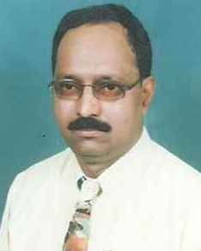
CURRICULUM VITAE

KUTUBUDDIN
Email: kutubuddin-395139@2freemail.com
PERSONAL SUMMARY
Being resourceful Bachelor of Arts Graduate with adequate experience, I intent to build my career by working with a professionally managed growth oriented organization in a more challenging & rewarding capacity.
EDUCATIONAL DETAILS

Bachelor of Arts (B.A) Graduation from Karnataka University Dharwar, India in the year 1979.

Technical Qualification
- Diploma in English Typewriting
- Attended Various Training courses from Saudi Arabian Airlines like Al Arabia Automated Reservation, S.A.R.S. GALILIO, Advanced Reservation, Amadeus, Sabre etc.

EXPERIENCE
- Twenty years experience in Kingdom of Saudi Arabia as Reservation and Ticketing Officer/ Corporate Manager from 1985 to 2004.
- Thirteen years experience in Dubai UAE as Corporate Manager/ General Manager / Sales and Marketing Manager from 05/05/2005 till 30/01/2019.

Skills

- Well versed with Internet & Email
- Sound Administration and Management Abilities
- Well working experience in Gulf
- Hardworking, Sincere & Punctual
- Huge Experience and highly motivated
- Can work under pressure
- Sincere and Honest

Languages | Speaking | Reading | Writing
English | Speaking | Reading | Writing
Urdu/Hindi | Speaking | Reading | Writing
Arabic | Speaking
Kannada | Speaking | Reading | Writing
DRIVING LICENSE DETAIL:
Have a valid U.A.E Light Vehicle License (Dubai)
- Date of issue : 13/11/2006
- Date of expiry : 13/11/2026
- Issued by : Dubai
PERSONAL DETAILS

Date of Birth: 20/07/1956
Expiry Date: 21/10/2019
Nationality: INDIAN
Marital Status: Married
Visa Status: Employment Visa

KUTUBUDDIN

