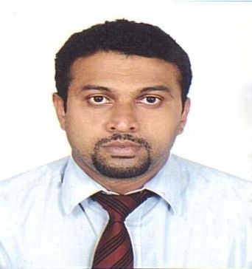
KALESH
Email – kalesh-395143@2freemail.com

OBJECTIVE

Seeking Marketing/Sales position in Banking with a major Public or private sector bank in UAE

SKILLS:
- Marketing, Sales in Banking
- Understanding of banking services and products
- Good verbal and written communication skills.
- Capable in leading the sales team and drive sales goals.
- Strong competitive drive and work ethic to succeed
- Proficiency in computer Skills

PROFESSIONAL EXPERIENCE
BANK in UAE since sep 2013 _ Aug 2016

Senior sales consultant – Personal loan

Summary of Responsibilities
- Sourcing the eligible customers and making them aware of our products.
- Verifying the documents as per our policy and pre-evaluating the same for checking the eligibility.
- Evaluating the Bank statement of the customer for analyzing debt ratio and calculate eligibility of particular product based on the analysis
- Preparing credit evaluation report based on the analysis of Bank statement
- Forwarding the prepared documents to Team head for further processing.
- Ensuring the services to the customers are delivered within the time frame
- Ensuring the individual targets is achieved every month on month basis

BANK in UAE (November 2007 - April 2013)

Retail Banking Group – Assistant Team Leader
Cross Sales – Abu Dhabi Direct Sales

Summary of Responsibilities
- Source Credit card and personal loan applications from salaried customers from list of companies

- Source credit card applications from self employed customers
- Preparation of card and loan proposals to be submitted to credit department and follow up for disbursals
- Prepare daily, Weekly and monthly plans for achieving the set target and execute on time
- Listing/Referral potential companies with the bank for Retail credit facilities
- Assisting team leader and team members to achieve the team target, document preparation, training of new team members, handling team in the absence of team leader.
- Handled different Banking Products i.e. Account Opening, Credit Cards, Personal Loan, Overdraft, Insurance & Certificates.

EXPERIENCE IN INDIA

Worked with TTK prestige Ltd as Territory sales executive in channel Sales (2006-2007)

Worked with Eureka forbes as Territory sales executive in channel Sales (2005-2006)

Worked with Bharati cellular ltd as senior sales executive in SME Sales (2003-2005)

EDUCATIONAL QUALIFICATION

Bachelor of Commerce (B.com) from Mahatma Gandhi University 2000-2003

PERSONAL PROFILE

Name : Kaleshkumar
Nationality : Indian
Date of Birth : June 1980
Marital Status : Married
Visa Status : Visit visa
Languages Known : English, Hindi &Malayalam Reference : will be furnished upon request

