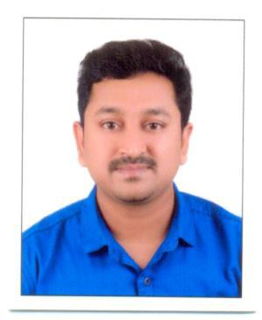
CURRICULUM VITAE

MELJO

Email Id : meljo-395228@2freemail.com

PERSONAL DETAILS
Date of Birth | : | 10-04-1984
Gender | : | Male
Religion & Caste | : | Christian, R C
Nationality | : | Indian
Marital Status | : | Married
Languages known | : | Malayalam,English, Hindi & Tamil

EDUCATIONAL QUALIFICATION
- BA (English Literature)

WORK EXPERIENCE

- 10 years experience Kalyan Jewellers Pvt. India Ltd. (Senior Head Sales Executive and Purchase Staff India & Abroad 2 years).
- 3 Years experience as a Teacher in Bihar.

- MANAGER IN BOMBAY GOLD AND DIAMONDS JEWELLERY NOW

DECLARATION

I hereby declare that all the above information provided is true to the best of my knowledge and belief.

Place: Vendore Date:

MELJO

