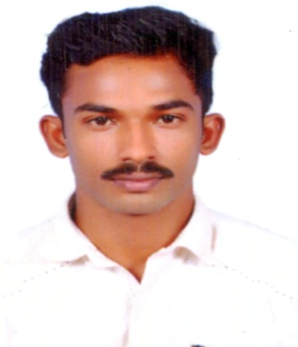
CURRICULUM VITAE

VIVEK
Dubai, U.A.E
E-mail: vivek-395272@2freemail.com

OBJECTIVE
Seeking a good career and holding a responsible position in the reputed organization and ensure credible performance to work towards exceeding the set goals contributes for the organization.
PROFILES
- Hard working and dedicated
- Good communication and analytical skills
- Can work under pressure with time bound performance
- Easy adaptability to situations

EDUCATIONAL ATTAINMENT

- Passed H.S.C from Kerala Board
- Passed S.S.L.C from Kerala Board
- B.Sc Chemistry from M.G University of Kerala

WORK EXPERIENCE

- Company name : Royal Kohinoor Jewellers
- Position : Sales Executive
- Period : From 2017 to Till
PERSONAL DETAILS

- Date of Birth : 23/03/1996
- Gender : Male
- Nationality : India
- Marital Status : Single
- Language Known : English, Hindi and Malayalam.
- Passport Details
- Date of Issue : 22/01/2018
- Date of Expiry : 21/01/2028

TECHNICAL QUALIFICATION

- Diploma in Computer Application
- MS Word
- MS Excel
- MS Dos
- MS PowerPoint

EXTRA SKILLS
- Demonstrated ability to work efficiently with others and communicate effectively with a variety of people, including event managers and peers.
- Self-motivated and seeking for a challenging career to grow with experience.
- A creative and highly talented individual.
- Aim to associated with progressive and forward looking organization
- Professional achievement

DECLARATION

I do hereby declare that the above mentioned information is true to the best of my knowledge and belief , Future , I am sure that if a chance is given to me to serve in your esteemed organization, I will give my full efforts toward the betterment.

VIVEK

