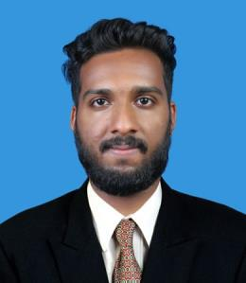
NEBEEL
MECHANICAL ENGINEER (MEP)

NEBEEL

E-mail: nebeel-395316@2freemail.com

OBJECTIVE

Seeking an opportunity with a good organization which demands the best of my professional ability in terms of technical and analytical skill there by achieving personal professional & organization growth

EDUCATION

B.E Mechanical Engineering

SreeSakthi Engineering College Coimbatore, Tamil Nadu, India (2014 – 2018)

Diploma in MEP [HVAC, FIRE FIGHTING &
PLUMBING]

MEDAC Enterprises Pvt.Ltd.Company, Calicut

EXPERIENCE

Mechanical Design Engineer
MEDAC Enterprises Pvt.Ltd.Company
(06/2018 – 05/2019)

- Experience in supervision & designing of building Mechanical system [HVAC, Drainage, water services and Fire Fighting] using relevant codes like ASHREA, SMACNA, NFPA, National plumbing code, uniform plumbing code.

- Sound knowledge to do HVAC load calculation & external static pressure calculation

- Pressure drop calculation and selection of chiller water pumps and fire pumps

- Ability to design and draft using Auto CAD and practicing REVIT

- Selection of control valves/Diffusers/Hot water system, chilled water system.

- Experience in site execution of all Mechanical systems and supervision

CERTIFICATES

- Heat Ventilation and Air Conditioning [HVAC]

- Fire Fighting, Plumbing

- Neuro-Linguistic Programming [NLP]

Page 1 of 2

NEBEEL
MECHANICAL ENGINEER (MEP)

PROJECT

SOLAR AIR CONDITION WITH AUTO TRACKING SYSTEM

- Solar tracking system is a power generating method from sunlight

- System is automatically change the direction to get maximum intensity of light

SOFTWARE SKILL

- AutoCAD

- Carrier HAP

- MCQUAY duct/pipe sizer

- Ductsizer

- MS Office

CORE COMPETENCIES

- Team work

- Communication skills

- Dedication towards profession

- Management skills

INTERESTS

- Design

- Maintenance

- Production

PERSONAL DETAILS

✓ Gender |  | :Male
✓ | Age | : 23,
✓ | D.O.B | :25/01/1996

- Nationality : Indian

- Visa status :visit visa

- Location : Dubai

DECALARATION

I do here by declare that the information provided above is true to the best my knowledge and belief.

Page 2 of 2

