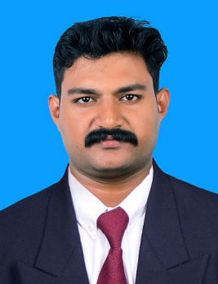
AJITH
Email: ajith-395341@2freemail.com

Professional Summary
To chart out a career in finance taking full advantage of my specialization in finance and to work with my full efficiency and integrity in long term association with any reputed organization.

- More than Two years of experience in a Chartered accountants firm, Accounting, Finalization of accounts, Accounts consolidation, Reconciliation, Tax assessment, Various Types of auditing, ROC Compliances, reporting and Documentation.
- Two years of experience in an Accounting and Tax Consultancy firm, Accounting, Budget development, Bookkeeping, Individual tax returns, Accounting management.
- More than Two years of experience in a Manufacturing Company, Accounting, Customer service, internal control management.
- Experience in preparing accounts, Finalize and consolidation like Balance sheet, Profit & Loss accounts and various control Accounts.
- Experience in preparing Sales Tax, Income tax, ROC Compliances and GST Return.
- Experience in day to day processing of Accounts payable and receivables to ensure that organizational finance were maintained in an effective and efficient manner
- Worked with the management team to implement the proper division of responsibilities.
- Completed all daily tasks and special assignments with an efficient and quality-driven approach.

Work History
JGS & ASSOCIATES (Chartered Accountants Firm) –Thrissur, Kerala
- Audit Officer Sep’2017 to Oct’2019

SATHYANARAYANA ASSOCIATES (Tax Consultancy Firm) –Thrissur, Kerala
- Accounts Manager Oct’ 2015 to Aug’2017

Green Rock Crushers & Mines PVT LTD – Thrissur, Kerala
- Assistant Manager, May’ 2013 to Sep’ 2015

Skills

- Accounts Reconciliation
- General Accounting
- Accounts consolidation and Finalization  
- Payroll Management
- Taxation
- ERP and Utility software
- Internal Auditing  
- Accounts Payable and Receivable  
- Inventory control

Educational Qualification
Professional Qualification : CS Executive – Pursuing
Institute : Institute of Company Secretaries of India
Degree : Bachelor of Commerce
College : Co Operative Arts & Science College
University : University of Calicut
Year of Passing : 2012
Academic Performance : 59%

Higher Secondary : Govt HSS Chembuchira
Exam/Board : Board Of Education, Kerala
Year of Passing : 2009
Academic Performance : 73%

Higher School : Govt HSS Mupliyam
Exam/Board : Board Of Education, Kerala
Year of Passing : 2007
Academic Performance : 87%

Diploma in Indian and Foreign Accounting (DIFA)-IAB

Personal Details
Date of Birth : 29th February 1992
Languages : English, Malayalam, Tamil Hindi.
Nationality : Indian
Marital Status : Single
Visa Status : Visit (Valid Till Jan’2020)

Declaration
I do hereby confirm that the information furnished above is true to the best of my knowledge and belief.

Place: Mupliyam AJITH
Date: 29-10-2019

