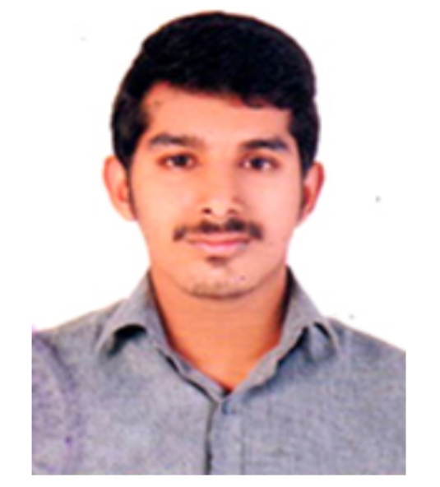  OBJECTIVE  Seeking a challenging and rewarding opportunity in an organization of repute, which recognize and utilizes my true potential while nurturing my analytical and managerial skill.  Hobbies  Cooking  Music  SPORTS  PASSPORT EXPIRYDATE:19/10/2025 |  | jithin  Email: jithin-395399@2freemail.com  work EXPERIENCE  Worked as an Operational Associate at Rivigo logistics Private Limited Kochi from 29th October 2018 to 3rd November 2019.  Worked as Logistics Coordinator at Terrier ConsultancyServices from 4th January 2015 to 10th March 2018.  demonstrated skills  Organizing shipments.  Coordinating drivers, vehicles Loads and journeys.  Operating IT systems.  Negotiating and agreeing contracts.  Developing and confirming schedules  Planning for and negotiating technical difficulties.  Preparing Paper works for regulatory bodies.  Liaising with and managing staff and shifts.  Waste management.  Monitoring stock.  Ensuring health and safety standards.  EDUCATION  Certificate in Logistics Excellence (CLEX)  Perusing MBA in Logistics and Supply  Chain Management from Bharathiar University Coimbatore. (First year completed)  Bachelors(Physics), Mahatma Gandhi University, Kottayam-Kerala-India.  ACHIEVEMENTS AND EXtraCURRICULARACTIVITIES  Head of College Unit, National Service Scheme (NSS).  The NSS is an Indian government-sponsored public service program conducted by the Ministry of Youth Affairs and Sports of the Government of India.  Member of National Cadet Crops (NCC)  The NCC is Youth Wing of Armed Forces with its Headquarters at New Delhi, Delhi, India. It is open to school and college students on voluntary basis  School football Team Captain  INTERPERSONAL SKILL  Commercial awareness  Ability to rapidly build relationship and set up trust  Confident and determined  Ability to cope up with different situations  Positive attitude  Innovative with capacity for creative thinking  DECLARATION  I hereby declare that the above mentioned details are true and are correct to the best of my knowledge and belief.  JITHIN

