NELSON

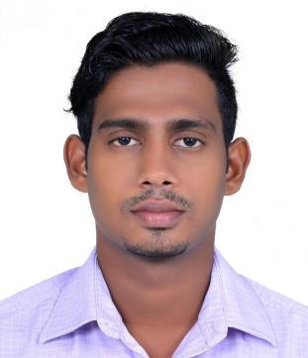

Email: nelson-395472@gulfjobseeker.com
Nationality: Indian
Date of Birth: 29-12-1993
Religion: Christian
Marital status: Single
Language known: English, Hindi, Malayalam

Visa expiry: 5th December 2019

CAREER OBJECTIVE:

Intend to build a career in the company with committed and dedicated people, which will help me to explore myself and secure a responsible career opportunity to fully utilize my training and skills. Willing to work as a key player in challenging and creative environment by making a significant contribution to the success of the company.

WORK EXPERIENCE:

- Company in Kerala, India
➢ Designation : Front Line Officer
➢ Duration : 11th July 2018 – 05th August 2019 (1.2 years)
- Duties and Responsibilities :

  - Approve loans within specific limits.

  - Meet with applicant to obtain information for loan applications and answer the questions about the process.
  - Analyze applicants’ financial status and credit to determine feasibility of granting loans.

  - Obtain and compile copies of loan applicants’ credit histories and other financial information.
  - Review and updates credit and loan files.
  - Analyzing Competitor Activities and Reporting to Related Officers.

  - Building, Maintaining and Retaining Healthy Business relations with Clients to generate more Business from Existing Clients.
  - Disbursement of loans.

PERSONAL COMPETENCIES

- Positive attitude
- Good leadership skill to set goals, empowerment and performance evaluation.
- Good interpersonal skills.
- Continuous learner.

- Team player.

ACADEMIC PROFILE:

QUALIFICATION | BOARD/UNIVERSITY | YEAR OF | INSTITUTION | PERCENTAGE
 |  | PASSING |  | OF MARKS
 |  |  | Berchmans Institute Of
MBA | Mahatma Gandhi | 2018 | Management Studies, | 59%
 | University |  | Changanacherry.Kerala
 |  |  | India
 | Mahatma Gandhi |  | Girideepam Institute of
BBA |  | 2015 | Advanced Learning, | 60%
 | University
 |  |  | Kottayam. Kerala India
Plus Two | Board of Higher |  | St. Joseph HSS,
 | Secondary Examination, | 2012 |  | 63%
 |  |  | Trivandrum
 | Kerala
S.S.L.C | Board of public | 2010 | Jyoti Nilayam HSS, | 67%
 | examination, Kerala |  | Trivandrum

INTERNSHIP:

- Completed Three days’ internship in Big Bazaar.
- Completed Three days’ internship in Aditya Birla Retail Limited.
- Completed Two months’ internship and organization study in ITC LTD COCHIN.

PROJECT WORK UNDERTAKEN:

- A Study on the “Effectiveness Of Performance Appraisal” at Popular Hyundai, Kottayam from the period of 1st December 2014 to 30st December 2014.

- Influence of Advertisement on Brand Recall of Meriiboy Ice-Cream in Changanacherry, Kottayam from the period 8th December to 31st January 2018.

CO-CURRICULAR ACTIVITIES:

- MS Office (Word, Excel, Power point, Access)
- Completed 3 days Excel Workshop
- Completed 4 days Digital Marketing workshop by I Cubes Pro.

EXTRA CURRICULAR

- Won 3rd place in Business Quiz at all India Management Fest conducted by CET, Pathanamthitta, Kerala.

- Won first prize in District Level Football competition 2010.

REFERANCE

Available on request

Date:

Place:

NELSON

