CURRICULUM VITAE
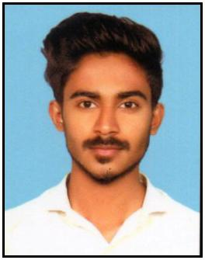

ABDUL

Email: abdul-395484@gulfjobseeker.com

OBJECTIVE:

To work in a challenging professional environment and there by utilize my talents, accounting skills and analytical ability.

SKILLS & STRENGTHS

Nearly 1 years experienced as professional accountant.
Highly proficient in Manual & Computerized accounting.

Accurate and fast accounting...

Excellent working relationship with Tally 9, Peachtree, Quick books, Wings, Microsoft Excel, Word
Additional skills include administration & Sales & coordination.
Sincere, punctual and hard working

Good communication and written skill in english

RELEVANT EXPERIENCE & ACCOMPLISHMENTS

Prepared Annual financial Reports with consolidated Balance sheet,

Income statement,

Stock report with category wise,

Fixed Asset & Depreciation

Handling basic Banking activities of preparation of cheques, cash deposits Handling and Controling Bills Receivable and Bills Payable
Handling main Cash and petty cash

Handling bills, vouchers and invoices

Reconciliation of Bank accounts

Implemented forms for stock maintaining warehouse wise Preparing daily and monthly reports to the Head office Issuing and receiving PDC

EMPLOYMENT

Auditing Assistant
Kerala,India, August 2018 – August 2019.

Responsible for: Making Accounting procedures up to finalization

QUALIFICATION

B.Com : Kannur University

Plus Two : Board of Higher Secondary, Kerala
SSLC : General Education Department, Kerala

Certifeid Professional Accountant

COMPUTER EXPOSURE

Accounting Software:
Peachtree,Tally,Quick books, Wings,

Office Automation |  | :
Microsoft Word, Microsoft Excel
PERSONAL DETAILS
Date of Birth |  | : 17-01-1998
Sex |  | : Male
Marital Status |  | : Single
Nationality |  | : Indian
Religion |  | : Islam
LANGUAGES KNOWN
To Speak | : English, Malayalam and Hindi
To Write | : English, Malayalam, Hindi and Arabic
PASSPORT DETAILS
Date of Issue |  | : 08/06/2018
Date of Expiry |  | : 07/06/2028
Place of Issue |  | : Kozhikode

UAE Visiting Visa Validity till 07th Jan2020 DECLARATION

I here by declare that the above –mentioned information is correct up to my knowledge and I here the responsibility for the correctness of the above mentioned particulars

Place

:

Yours truly,

Date

:

ABDUL

