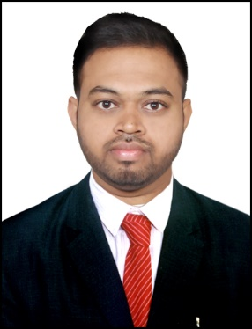
Name: Rajesh
Email: Rajesh-395486@gulfjobseeker.com
Visa Status: Visit Visa
Visa Expiration: Feb 1st 2020

CAREER OBJECTIVE:To secure a challenging position in a reputable organization to expand my learnings, knowledge, and skills.

Work experience:

1.
Duration: September 2018 to October 2019
Designation: Junior Engineer
Location: Hyderabad, Telangana, India
2. (January 2016 to September 2018)
Teller(Western union Agent) (Global Exchange)
Location: Fairfax county, Virginia, USA

ACADEMICS:
CORE SKILLS  - AutoCAD  - STAAD pro  - REVIT  - MS OFFICE  - MS PROJECT  - MS EXCEL  PERSONAL STRENGTHS  - Good leadership skills, motivational skills and team handling ability  - Adaptive in nature  - Flexible to necessities  - Excellent communication and presentation skills.  - Passionate towards work | 2015-2018 (USA) MS in Project Management-Virginia international university, Virginia (Discontinued) 3.0 GPA (scaling out of 4.00)  2010 – 2014 BE in Civil Engineering – TKR College of Engineering, Hyderabad Passed with 68.5% Projects: Year : 2013 Duration : 2 months Topic : Green Building Description : Material and cost comparison between Conventional and Green building Year : 2014 Duration : Four Months Topic : structural pavement design. Description : The Project was done for the widening and strengthening of pavement.  2008 - 2010 Higher Secondary (MPC) – Narayana Junior College - Passed with 84%  2008 SSC – Gowtham Model School, Nizamabad - Passed with 84%

Engineering Responsibilities | Teller/WU  Responsibilities
- Setting out sites and organizing facilities.  - Setting out sites with auto level.  - Experience with AutoCAD.  - Checking technical designs and drawings to ensure that they are followed correctly.  - Supervising contracted staff and counseling junior or trainee engineers  - Ensuring projects meet agreed specifications, budgets or timescales.  - Resolving technical issues with employer’s representatives, suppliers, subcontractors and statutory authorities.  - Liaising with clients, subcontractors and other professional staff, especially quantity surveyors and the overall project manager.  - Providing technical advice and solving problems on site.  - Preparing site reports and filling in other paperwork. | - Cash checks pay bills process money orders, wire money nationally and internationally.  - Proficient in exchanging 30 different countries.  - Maintained balancing record with 100% rate of accuracy.  - Recorded amounts received and prepared reports of transactions.  - Processed exchange and foreign currency.  - Proficient in using computers and other office equipment, handle complaints and cash inflows and outflows  - Maintain records to comply with laws and regulations, examined checks identification and endorsement.  - Delivered prompt, accurate and excellent customer service.

BEYOND ACADEMICS

- Have participated in “STAAD.PRO” workshop which was held by Alcheringa’14 IIT Guwahati at Teegala Krishna Reddy college of Engineering.
- Have Organized in technical event on the topic “AUTOCAD” design at annual national level symposium, Advitiya-2013 held in Teegala Krishna Reddy college of Engineering
- Have actively participated in “HALF MARATHON” which was held by T.K.R SPORTS FOUNDATION

