APRIL  Email Address: april-395514@gulfjobseeker.com  OBJECTIVES:  To work hard with full of determination and dedication to achieve organization as well as personal goals, to learn new things and adapt the organizational environment in your company that would give me new knowledge and skills.  Work experience | 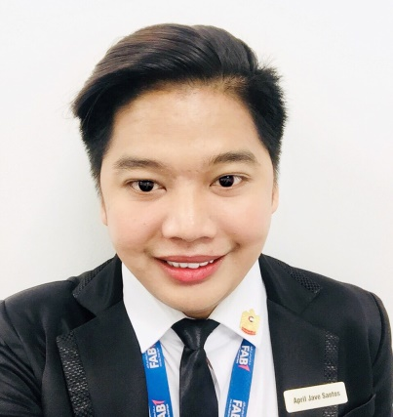
Archive Clerk/Front Office Receptionist/Administrative Assistant
Dubai, UAE
September 2017-October 2019

- Greet clients and visitors with a positive, helpful attitude.
- Assisting clients in finding their way around the vicinity.
- Coordinate with all the staff, security, IT maintenance and cleaner.
- Helping maintain work place security by checking and collecting badges as necessary.
- Answering, forwarding and screening phone calls from the staff.
- Receiving such documents from the clients and send it to the staff.
- Schedule the appointments if necessary.
- Managing the bookings of all the meeting rooms in the office.
- Ensure the stationary and pantry supplies are adequately stocked by ordering as and when required.
- Sorting and distributing mail and other office supplies.
- Provide excellent customer service.
- Ensure knowledge of staff movements regarding rules and regulation and responsibilities as promoter

Freelance Event Coordinator
Rizal, Philippines
August 2014 – May 2017

- Works closely with Event Manager to ensure all required tasks are accomplished and complete on day-of-event.
- Attending calls/emails/queries
- Follows Guidelines, Assist in negotiations and obtaining quotes with external vendors to coordinate best goods and services.
- Reporting to the Events Director, to coordinate and provides support for all kind of events
- Discuss layout/decoration options with clients and conduct venue walk-thru.
- Greets and directs guest to the event site
- Coordinate to our all suppliers like make-up artist, designer, emcees, photographers and catering.
- Manages logistics in preparation for events including setting up displays, presentations, and equipment.
- Maintains client and vendor relationships, and serves as point of contact on day-of-event.
- Occasionally, assigned being Host/ Master of Ceremony.

Assistant office Coordinator/Secretary
Municipality of San Mateo Rizal Philippines/ Special program of employment student.
March 2012 – May 2015
- Handling secretarial duties, reception, and inquires.
- File and update contact information of employees and barangay staffs.
- Prepare and disseminate correspondence memos and forms.
- Generate weekly and monthly reports.
- Required to file confidential documents.
- Operate various printers, photocopiers, scanners as well as related machines in the office.
- Maintain daily record of staff attendances.
- Data entry of receipts.
- Barangay census, survey for population and Economy.
- Sports Committee.

FREELANCE PRIVATE TUTORIAL CLASS FOR GRADE SCHOOL
St. Matthews School/Nuestra Senora School Philippines
June 2016 – March 2017

- Prepare a lesson related to the topic of the school teachers.
- Create an assessment regarding to the lesson of the students and discuss it clearly.
- Give a summary test and evaluate the results.
- Helping the students to do their homework and projects.
- Identify the strength and weakness of the students when it comes to discussion.
- Review the previous lessons
- Provide an excellent and effective teacher to the students.

PRACTICUM ENGLISH TEACHER
Ampid National High School, Philippines
October 2015 – March 2016
- Coordinate instructional efforts with lead teacher.
- Design and implement lesson plans and curriculum.
- Tutor students and assist with assignments and concepts.
- Organize and distribute learning resources.
- Monitor students during class work and exams.
- Manage student behavior as appropriate.
- Plan and develop teaching aides as instructed.
- Provide assistant to teachers in terms of preparing lesson outlines.

HIGHLIGHTS OF QUALIFICATON
- A Bachelor Degree experience in providing outstanding administrative work.
- Knowledge in File Management
- Computer literate (word and excel)
- Good communication Skills
- Good work habits and discipline.
- Ability to handle pressure and stress
- Multi-tasking
- Solid services and product knowledge
- Respectful and patient with regards to explaining to my point of view.
- Adventurous, willing to learn new things.

EDUCATIONAL ATTAINMENT

Class of 2012-2016 (College)
Bachelor of Secondary Education - Major in English
ALL NATIONS COLLEGE-Soliven Avenue Mayamot Street Antipolo City, Rizal Philippines

Class of 2008-2012(High School)
San Mateo Natonal High School Ampid2 Annex Salamat St. Ampid 2 San Mateo Rizal

Class of 2002-2008 (Grade School)
Justive Vicente Santiago Elementary School B. Mariano St. Ampid 2 San Mateo Rizal

SEMINARS/WORKSHOP ATTENDED

First Regional Students Teachers
Congress Ynares Covered Court, Antipolo City, Rizal, Philippines

Certificate of Completion of Field Study
All Nations College, Rizal, Philippines

Certificate of Completion of Special Program Employment Student
Congress Ynares Covered Court, Antiopolo City, Rizal, Philipines

PERSONAL DATA

Birth Date: April 8, 1995
Sex : Male
Civil Status: Single
Citizenship: Filipino
Language Spoken: English, Filipino, Arabic (Basic)

CHARACTER REFERENCE
Available upon request.

I hereby certify that all information given and furnished are true and correct to the best of my knowledge.

.

___________________
Applicant’s Signature

