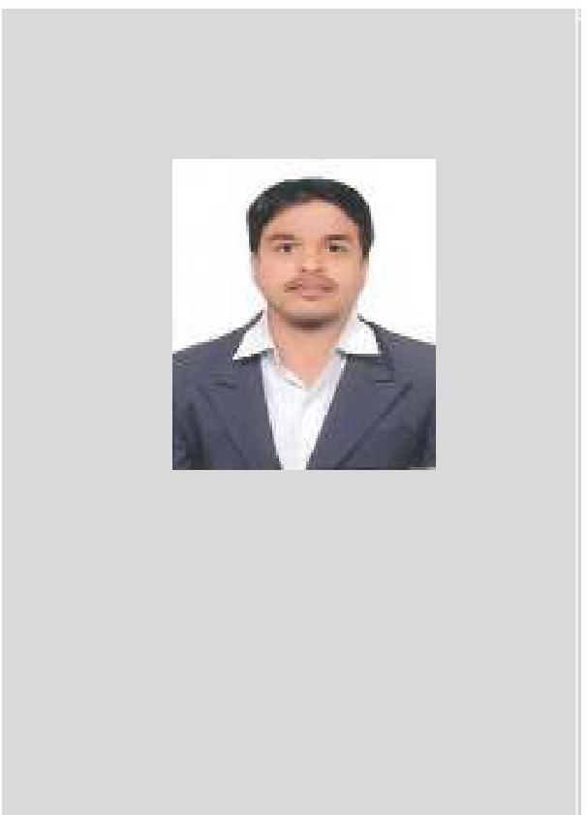

YASER

CIVIL ENGINEER Total Experience

07 Years (In Total)

DM Approved Engineer (G+4)

Society of Engineers Affiliation (UAE):2020

Industries Worked & Key Expertise

Construction Project Management, Site coordination

Monitoring and Controls, Reporting and Updates

yaser-395559@gulfjobseeker.com

`

Dubai UAE

CAREER OBJECTIVE

Achieving a professional position which facilitates me for the successful utilization of educational knowledge, skills and experience more meaningfully in a dynamic work environment where opportunity is possible for the growth.

Excellence and leading to be recognized globally by offering a professional service to the society and to the stakeholders for the achievement of mission and vision of the company to develop personally and

professionally with continuous improvement of solid domain techniques

SUMMARY

A professional Civil Engineer with 07 years of professional experience with EPC and multicultural environment in different organizational setups like Building construction, Commercial Building works, Infrastructure and Landscaping work. I have experienced Executing, planning, monitoring and control in multidisciplinary activities.

I have the ability to monitor and Executing large scale of activities and generate versatile reports for monitoring, management and control. Worked in many projects such as Commercial Buildings, Infrastructure, Residential Development Projects and Interior Fit Out which includes High rise buildings, Commercial buildings, Luxury Villas and other Fit Out development projects.

Currently Working in Ali Al Tamimi Contracting LLC, UAE as a Civil Site Engineer and coordinator.

I worked in Oman Untied engineering LLC Muscat Oman as a Project coordinator and Site Engineer.

EMPLOYMENT

CIVIL SITE ENGINEER and COORDINATTOR (September 2018 to Current)

Dubai, UAE

Project 1: Al Hamriya Residential Building (G + 3 + 2R)
Contract Value: 7.45 million USD
Client: Al Ghurair Properties & Investment Company

DUTIES AND RESPONSIBILITIES

- Planning and Execution of work as per design drawing.

- Report to the Project Manager about the progress and comparison between plan and actual progress and study impact of alternative approaches to work.

- Maintaining and monitoring project plans, project schedules, work hours, budgets and expenditures.

- Distribute minutes to all project team members.

- Create a project management calendar for fulfilling each goal and objective.

- Solve the technical quires/Issues with consultant for the project.

- Submission of MAS & coordinate with consultant for approval.

- Submission of shop drawing & coordinate with consultant for approval

- Managing project operations with a view to ensure timely accomplishment of targets within the scope, time and cost parameters.

- Developing the planning schedule for Engineering, Procurement and Construction based on contract requirements.

- Conducting weekly evaluation meeting with team and subcontractors for evaluating progress identifying the areas of concerns (if any) and took initiative for recommended action for eliminating the same.

- Follow the major quantities of the project as per productivity norms.

- Project progress monitoring & co-ordination with concerned departments to take the job ahead on scheduled basis.

AREAS OF EXPERTISE

Execution of activities

Resolving the technical queries

Resolving all the issues related to site

Maintaining Site related all documents properly

Defining Milestones

Variation and Technical quires Cost Control

Supplier Quotations Commercial Comparison Coordination with suppliers Tracking Material Delivery Monitoring & Updated Project Management

SKILLS

Interpersonal sensitivity Punctual

Good Communication

Inventiveness

Creativity

Disciplined

Team Work

Self-motivated

Time Management

Adopting to dynamic environment

EMPLOYMENT

PROJECT COORDINATOR AND SITE ENGINEER (March 2017 to August 2018)

Oman United Engineering Services LLC Muscat Oman

Project 1: Construction of Police Station Complex Samail Muscat, Oman
Contract Value: 34 million USD
Client: Royal Oman Police, Oman

DUTIES AND RESPONSIBILITIES

- Prepare and submit daily, weekly and monthly progress report to management and consultant for the project

- Preparation of Material Procurement program and Material reconciliation reports Close monitoring of subcontractor’s schedule

- Documenting and following up on important actions and decisions from meetings.

- Solve the technical quires/Issues with consultant for the project.

- Ensuring project deadlines are met.

- Determining project changes.

- Developing project strategies.

- Reviewing invoices and certifying the payments
- Monitoring productivity of resources as a resource controller.
- Preparation documents required for Extension of Time (EOT) Claims.

- Instrumental in evaluating the daily targets for the team (Short Interval Control)

EMPLOYMENT

Civil Site Engineer (February 2016 to February 2017)

S.J. Contracts Pvt. Ltd. Pune, India

Project: G+6 residential project Amar WESTVIEW in Pune, India

Client: Amar Builders and Developers

DUTIES AND RESPONSIBILITIES

- Experience in preparing schedule, implementing and monitoring at site.

- Monitoring the quality, execution as per specifications and supporting the Site Superintendent in all technical, logistical and organizational aspects of the work.

- Conducting site progress review meetings with subcontractors for monitoring of project identifying problems related to work progress & highlighting of the same.

- Complete resource planning including labour & non labour (Machinery) as per project scope.

- Preparation & submission of Progress Reports/Charts and submitting to the Department Heads.

- Assist Production personnel in defect reduction activities.
- Ordering the materials by referring Bill of Quantity for the projects

COMPUTER LITERACY

Auto CAD

Primavera P6

MS Project

Microsoft Excel

Power Point

Microsoft Word

MS Office

PERSONAL INFO

DATE OF BIRTH : 27 April 1990

GENDER : MALE

AGE : 29

RELIGION : ISLAM

DRIVING LICENSE : Oman

NATIONALITY : Indian

EMPLOYMENT

Civil Engineer (May 2013 to July 2015)

Kolte Patil developer’s Ltd Pune, India
Project: 400 Acres Township Project (LIFE REPUBLIC)

DUTIES AND RESPONSIBILITIES (Post Contract Activities)

- Execute the job as per ISO procedure & maintaining the record for the same.
- Analysis of quantities as per drawings.

- Checking and certification of RA bills as per work done.
- Monitoring the progress of the project at different stages of its development
- Making adjustments to schedules if necessary

- Ensuring that all the separate elements of the project fit together and are working towards a common aim.

- Follow up the job in every stage and reporting to planning engineers and Managers.

- Making transportation arrangements for delivering the materials to client.

- Communicate with Design and engineering department to clarify technical doubts.

- Communicate with Subcontractor engineers to fulfil their requirement.

EMPLOYMENT

Trainee Civil Engineer (May 2013 to July 2015)

Gulmohar Developer’s Pvt Ltd Pune, India
Project: G+8 Luxurious Residential Project Pune, India

KEY SKILLS AND HIGHLIGHTS

- Adaptive to new work places and easily grasp new concepts
- Good communication skills with a pleasant manner and pleasing personality

- Have a conscious sense of manners coupled with strong sense of punctuality
- Good team player with professional outlook
- Good analysis skills
- Able to persuade and maintain good relations

- Excellent communication and linguistic skills, lateral thinker, aggressive achiever and ability to work under pressure

- Multi-Tasking, good observation and grasping abilities
- Primavera P6, Microsoft Office, MS project

PROFESSIONAL EDUCATION

Bachelor Engineering in Civil Engineering

Shivaji University Kolhapur, India

REFERENCES: References will be available upon request

I do hereby certify that the information given above are true and correct to the best of my knowledge.

