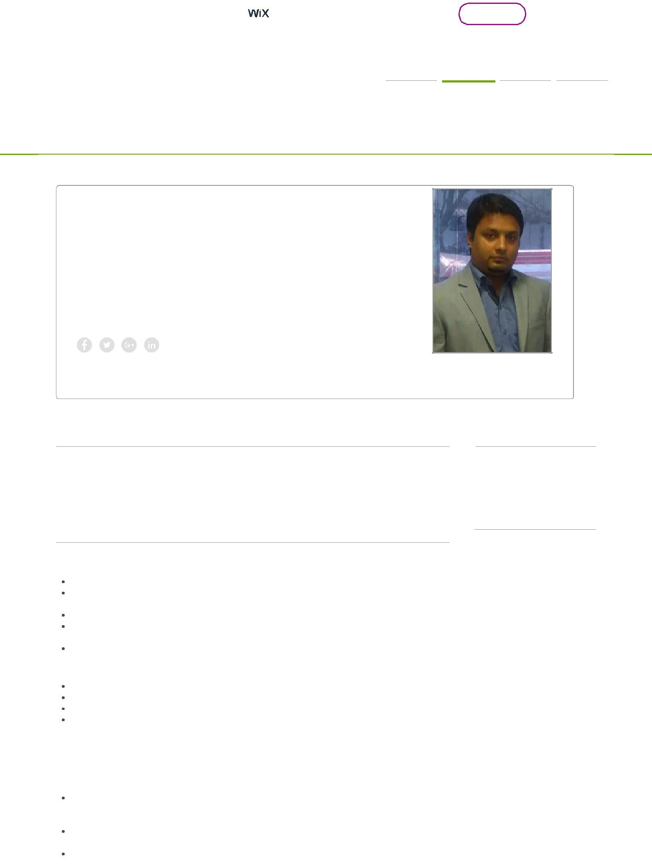

Rohit

Senior relationship manager in HDFC BANK

HOME CV PROJECTS CONTACT

CV

Rohit

Pimpri Pune Maharashtra Indian

E-mail: rohit-395580@gulfjobseeker.com

Professional info

MBA in Marketing Management (shobhit university) and BBA in (Tilak Maharashtra Vidyapeeth) Marketing with 8+ years of work experience in marketing & sales (Banking),worked with few of the best banks (HDFC,Standard Chartered bank,) currently with Kotak Mahindra Bank as a Branch Sales Manager

Work experience

Senior relationship Manager. HDFC BANK LTD

Sept 2017 - till now

Reported to the Branch Manager

Acquired and manage Resident UHNI’s and corporate from open market and from different strata of working environment.

Deal in end to end banking solution form CASA TD to limits and WC funding.

Keep clients updated on new and innovative investment products like Equity, insurance, structure notes, Mutual funds etc and advice them on that. Build institutional relationships through networking and referrals.

Achievements:

Recommended for Silver Star in first quarter itself for super performance.

Currently managing 172 crs portfolio with SHNW and corporate in books.

Instrumental in disbursing 10 crs of WC limits in 2nd quarter itself.

Achieved portfolio level income in 5 months,

Sales Manager. Kotak Mahindra Bank.

Oct 2015 - August 2017

Handling a team of 7-8 assistant acquisition managers for sourcing of Current & Savings A/c, Trinity accounts, Home-loan, Business-loan, OD/CC, LOAN against property and Insurance.

Manage the gamut of task of motivating, monitoring and training of Branch and sales Team.

Conducting BM-SM meeting and planning activities of team in corporate, societies, colleges clubs etc

Languages

English,

Hindi,

Marathi,

Punjabi,

Skills

Banking,

Team handling,

Portfolio Management

Customer Service,

Relationship Management,

Business strategy,

Retail Banking,

AML,

KYC,

Compliance,

Fraud Management,

Risk Management,

Operation,

Audit

1/3

Conduct team meeting weekly & monthly to review on the performance of team member |  | Start Now
This site was designed with the | .com website builder. Create your website today.
and about their productivity

Achievements:

Instrumental in developing the branch acquisition team

Achieved 130% in life insurance budget,

Achieved 107% budget in securities accounts

Achieved 97% budget in New accounts acquisition

Achieved the target of 0% attrition

In a six months I have been promoted to bigger branch

second Level achiever in trinity contest at national level

Six months achieved current account and saving accounts numbers

Recognition received from business head and national head

.

Priority Relationship Manager. Standard Chartered Bank.

May 2014 - Oct 2015

On-boarded premium profile customers. Profile like continent head, country head &
programmer heads etc in list.

AUM of close to INR 2 crores has been transferred.
FUM growth of close to 30 % in 6 month. Currently managing INR 21crs of Resident and INR 9crs of Non-Residents.
AUM growth of 24% in YTD 2014.
Achieved 83% of Dec 2014 budget.
Reporting to the Branch Manager
Build institutional relationships through networking and referrals.
Manage portfolio of Preferred Banking for HNI/NRI, Investments includes Equity, Structured products/PMS and Insurance, Liabilities under Sales and Acquisition of Savings Account business for the city.
.

Achievements:

Achieved 83% Business Goal,

Contributed 60% in branch Goal

Personal Banker - HDFC BANK LTD

Jan 2013 - May 2014

Generate new business to achieve defined sales targets
Build and deepen relationships with existing Wealth Customers to achieve increase in share of wallet and revenues.
Provide professional customer service to achieve a high percentage of customer
satisfaction and retention.

Ensure coverage of customer base in accordance with the Group approved Relationship Matrix.
Ensure compliance with these policies and procedures on an ongoing basis.
Any suspicious transaction must immediately be reported to the supervising officer.

Achievements:

Received Star performer award,

Qualified for every cash prize and gift for all contest.

Highest NTB sourcing with Higher IP

Achieved 100% Business Goal,

Contributed 70% in branch Goal

Joined as Assistant Manager for Financial planner position and

There after successfully handled position of welcome desk, Personal banker (PB sales) And promoted Relationship Manager in Pashan Branch

SALES OFFICER - NSB BPO SOLUTION & RDS MANAGEMENT ASSOCIATE WITH STANDARD CHARTERED BANK

Fed 2007 - March 2011,

Taking care of the top most vertical of Standard in credit cards called Visa Cards
Emirates & Platinum

Advising & cross selling of Insurance,
Cross selling of Home loan, Car loan & Personal loan.
Giving them post sales service and maintain a rich relationship with them.
Promotions to reach all different segments of customers.
Upgrade customer normal credit,
Emirates & Platinum cards only for celebrities and high value customer,

Target Market & Penetration:

Mainly targeting senior management employees in an organization.
Giving presentation at major organizations, providing clarity about the product to the newly

2/3

inducted employees.
This site was designed with the .com website builder. Create your website today. Start Now Meeting branch managers at a regular basis to get leads about privileged clients.

Getting references from existing clients to set up a new chain of customers.
Maintaining relationships with the relationship managers of various branches and
exchanging leads for cards and savings account.

Networking with Kotak Prime to source customers buying high end cars and approaching them for our product line.

Achievements

I got awarded for the Best SALES PERSON for PAN INDIA for the year 2009 & 2010. Also was certified for the best Sales person inner council for the year 2009-10.

Education

Sobhit University.Masters in Business Administration (Marketing)

2012 - 2014,

I have completed my MBA from Shobhit University, in the field of Marketing. It was a distance learning education, I have cleared my MBA with first division.

Tilak Maharashtra University. Bachelor in Business Administration (BBA)

2007 - 2010

I have completed my MBA from Tilak Maharashtra University, in the field of

Marketing, I have cleared my BBA with second division.

3/3

