Curriculum Vitae
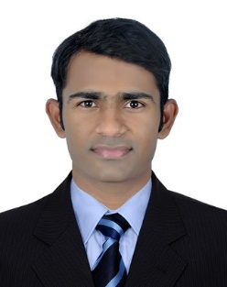
Name: Praneeth
E-Mail: praneeth-395591@2freemail.com

CAREER OBJECTIVE:

Looking for suitable opportunity to lead where I can explore my skill sets and bring them to effective use for achieving the organizational objectives by providing the guest with efficient services.

ACADEMIC QUALIFICATIONS:
- Successfully completed degree (B.A) from kakatiya university Telangana.
- Successfully completed intermediate from the board education Telangana
- Successfully completed s.s.c from the board of secondary Telangana.
AREA OF INTEREST:
- Driver.
COMPUTER SKILLS
- Microsoft office –word, excel, access and PowerPoint.
- Good understanding of the property management soft wares ( Eg: Opera, FBM)
- Computer reservation system Amadeus.
PERSONAL SKILLS:
- Cross training done in housekeeping administration.
- Cross training done in the concierge(bellman)
- Problem/guest complaint handling
- Team player
- Close attention to detail.
- Navigating property management systems.
- Able to handle any emergency situations that may arise.
- Training up new Room Attendants to a high standard
- Good written and communication skills.
- Quick learner, self-starter and hard worker with high level of integrity.
- Adaptability to new atmosphere.

WORK EXPERIENCE
- Currently Working as a housekeeping room attendant from 11.09.2016 till date
- Worked in Intercontinental Hotel, Muscat as a Self-checker from 01.09.2015 to 28.08.2016
- Worked in Hormuz Grand Hotel, Muscat as a Room Attendant from 28.08.2014 to 20.08.2015
- Worked as a SALES cum Driver from 02.03.2012 to 01.05.2014 at India Hyderabad
PERSONAL PROFILE
Name : Praneeth
Date of birth : 04.03.1993
Gender : Male
Nationality : Indian
Religion : Hindu
UAE driving license: (Manual)
LANGUAGES KNOWN
- Telugu
- English
- Hindi
- Tamil
PERSONAL
- Strong sense of responsibility.
- Keep to help out colleagues who are struggling with their duties.

I hereby declare that the above information given above is true to the best of my knowledge and belief.
Yours faithfully
PRANEETH

