ATTA
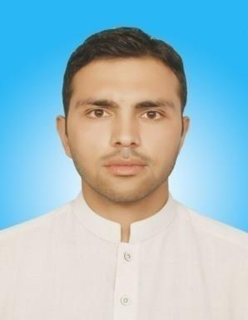

(CIVIL ENGINEER)

E-mail | : | Atta-395621@gulfjobseeker.com
D.O.B | : | March 6, 1995
Recent Location | : | Abu Dhabi (On Visit Visa Valid November 17, 2019 to
 |  | February 14, 2020)

CAREER OBJECTIVE:

I would like to contribute to the company’s growth and prove to be a valuable asset to the organization, To work with full dedication in challenging atmosphere, while adding some significant values to the organization to the concern goals and gain professional skills while working with support of competent peers and guidance leader which will further enhance my career ambition of rising to peak of success.
KEY QUALIFICATION:

B-Tech Honor in Civil Engineering along with CGPA 3.66/4 from CECOS University Peshawar, (Pakistan).

Computer Skills:

Primavera P6 |  | Microsoft Word | 2010
AutoCAD | 2010 | Inpage | 2010
SAP | 2000 | Microsoft Excel | 2010
Typing |  | Web browsing, Email etc

EXPERIENCE:

Company

: CONSTRUCTION COMPANY in MARDAN (PAKISTAN).

Position

: CIVIL ENGINEER

Duration

: SEPTEMBER 1st, 2015

to

OCTOBER 1st, 2018.

Projects

: CONSTRUCTION OF ABDUL-WALI-KHAN UNIVERSITY (MARDAN) & MALAKAND UNIVERSITY, KPK (PAKISTAN).

DUTIES AND RESPONSIBILITIES:

Preparation Of BBS And Estimating The Quantity Of Required Materials.

Supervision Of Cutting, Bending And Fixing Of Rebar According To Bar Bending Schedule.

Coordination With Client And Subcontractor For Smooth Flow Of Work.

To Make Payments Bills And Site Related Reports.

Supervision of Quality Control Tests For CONCRETE Such As Slump Cone Test, Compaction Test, And Compressive Strength Tests For Cube And Cylinder Of Concrete,

Making Drawings 2D+3D By Using AutoCAD.

FINAL YEAR PROJECT:

Characteristics Of Concrete Using Foundry Sand Slag As Partial Replacement.

LANGUAGES:

ENGLISH

URDU

PASHTO

PERSONAL SKILLS:

Hard Working And Loyal.

Problem Solving And Decision Making Skills Creative And Innovative Attention To Detail
Positive Work Attitude And Team Player.

Having Ability To Work With Different Nationality People.

HOBBIES AND INTERESTS:

Long Drive

Hiking

Reading Books And

Do research On Modern Technology

Tourism

REFERENCES:

Will Be Provided Upon Demand

