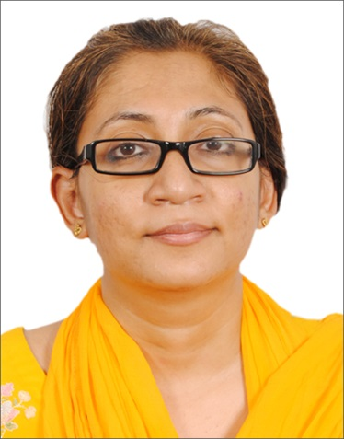
Aarfa

Email: aarfa-395625@gulfjobseeker.com
Summary

Has a M.D.S degree in Periodontology with First division from Krishnadevaraya College of
Dental Sciences and Hospital, Rajiv Ganghi University of Health Sciences,Karnataka. Got
evaluated as GP (Dentistry) MOH.

Objective

Looking for an opportunity to make a difference with my diverse skills and abilities as Periodontist. I believe that I can be a good addition to the hospital team due to my experience and educational background.

Highlights

- Rich experience in flap surgery and mucogingival surgery.
- Participate in the briefing and discussion with the team.
- Explain to the patients the effect of the good oral hygiene.
- Well acquainted with pre anaesthesia check up and premedication to patients before surgery.
- Ensure the supportive periodontal therapy to the patient
- Ensure that the patients have minimal morbidity after surgery.
- Great ability to communicate verbally or in print.
- Excellent interpersonal skills.

Achievements

- Evaluated as GP (Dentistry ) MOH

- Successfully completed BALS (Basic Advanced Life Support) in year 2011.

- Member of Indian Society of Periodontology which is a scientific body. My membership number is 85154.

Conference and Paper Presentation at a Glance

- Karnataka State Conference:
IDA Karnataka Bangalore 2010
IDA Karnataka Mysore 2011(Paper Presentation).

- National Conference:
ISP 2010 – Bangalore (Poster presentation)
ISP 2011– Ahmadabad (Paper Presentation)

Academics

S.N | NAME OF EXAM | % OF MARKS | YEAR OF PASSING | INSTITUTION/  COLLEGE | UNIVERSITY
1. | BDS | 61.43% | 2008 | Syamala Reddy Dental College, Bangalore | Rajiv Ganghi University
2. | M.D.S.  Periodontology | 67.33% | 2013 | Krishnadevaraya College of Dental Sceinces, Bangalore | Rajiv Ganghi University. Bangalore

Experience

S.N | PLACE | FROM | TO | POSITION | DURATION
1. | SUNKRIS DENTAL HEALTH CARE,  HSR LAYLOUT,  BANGALORE | 01 st JULY 2013 | 20 th JULY 2016 | GENERAL PRACTIONER  (DENTISTRY) | 3 YEARS 15 DAYS.
2 | College of Dentistry , Ajman | 15.01.2019 | 15.05.2019 | General Practioner (Dentistry) | 1 year

Professional Disclosures

Dental Registration

- (Karnataka State Dental Council)

Personal Disclosures

Sex: Female
Married: Yes
Date of Birth: 11 Nov 1981
Nationality: Indian

The Information given above are true to the best of my knowledge and belief. I am liable for appropriate action if any information given above is found to be incorrect.

Date: Yours Faithfully,

Place: SHARJAH (Aarfa)

