CURRICULUM VITAE
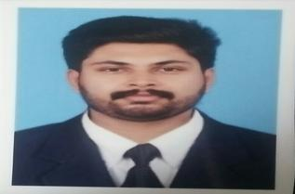

PERSONAL DETAILS

NAME: SHAFAF

NATIONALITY: INDIAN

DATE OF BIRTH: 15-09-1992

EMAIL: shafaf-395634@gulfjobseeker.com

EDUCATIONAL

- BACHELOR OF COMMERCE CALICUT UNIVERSITY BCOM (2012-2016)

- PLUS TWO GOV VOCATIONAL HIGHER SECONDARY SCHOOL KINASSERY (2009-2010)

• SSLC CALICUT ISLAMIC RESIDENTIOL HIGHER SECONDERY SCHOOL (2007-2008)

ADDITIONAL COURSES AND ACHEVMENTS

- NCPT COMPUTER EDUCATION

- ADVANCED DIPLOMA IN FINANCIAL ACCOUNTING

- MS OFFICE

- MANUAL ACCOUNTING

- TALLY ERP9

- DRIVING LICENCE NO:11/14475/2010 ( INDIA

LANGUAGES

• | ENGLISH | ( BASIC SPEEK | AND WRITTEN )
• | TAMIL | ( BASIC SPEEK | )
• | HINDI | ( BASIC SPEEK AND WRITTEN )
• | MALAYALAM ( FLUANT SPEEK AND WRITTEN )

EMPLOYMENT HISTORY

• CENTRAL TRADING COMPANY ERNAKULAM ACCOUNTING 2019 CURRENT

- FLEETROYS POLYMERS MARKETING ACCOUNTIG ( 2016 – 2017 )

KEY SKILLL

- GOOD COMMUNICATION AND INTER PERSONAL SKILLS

- GOOD TIME MANAGEMENT SKILLS

- ABILITY TO WORK UNDER PRESSURE

- CREATIVITY IN SOLVING PROBLEMS

- HIGH COMMITMENT IN TEAM WORK

HOBBY

- TRAVELLING

- DRIVING

- COMMUNICATION

References available upon request

I hereby give consent for my personal data included in my

