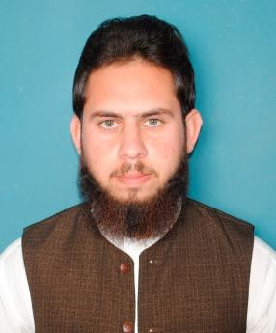
MR. ASADULLAH

Email: asadullah-395636@gulfjobseeker.com

Post applied for: Mechanical Engineer/supervisor/foreman/inspector/HVAC Engineer/HVAC Technician / Machine Operator

Professional Objectives:

- To achieve high career growth through a continuous learning process, keep myself dynamic and to contribute for the growth of organization.

- Currently looking for a job position in an organization that needs an individual who will work as an engineer and has the ability to work with a team for a particular purpose.

Personal Information:

Date of Birth:
Religion:

Marital Status:
Domicile:
Nationality:
Visa Status :

January 04, 1995
Islam
Married
Swat
Pakistani

Visit

Educational Qualification:

2013 – 2017

Bachelor in Mechanical Engineering

Work Experience: 2 years
Details of Experience:

- Training From 27th July 2016 to 24th August 2016 in Diff. workshops Organization: HEAVY MECHANICAL COMPLEX

  - Production and planning and control
  - NDT laboratory
  - Heat Treatment

  - Assembly shop
  - Machine shop
  - Fabrication shop
  - Material testing laboratory
  - Forging unit

  - Pattern shop
  - Quality control

- From 1st June 2017 to 31st October 2017
Organization: SKY FOOTWEAR PLASTIC INDUSTRY (PVT) LTD
Position: Trainee Engineer

- From 21st Nov 2017 to 16th May 2018
Organization: DAUDSONS INDUSTRIES (PVT) LTD
Position: Trainee Engineer

- From 4th June 2018 to 30th June 2019 Organization: DAIKOOL

Position: HVAC Engineer (sales and services)

Professional skills:

- Auto CAD Certified

- Creo 3.1
- Microsoft Office (Word, Excel, Power Point)
- Computer operations
- Troubleshooting of General Computer Software’s

Interpersonal skills:

- Strong Communicational Skills (spoken and written).

- Proficiency in various MS Office applications (Excel, Word) and other IT application.

- Team Worker/builder, proven record in working in collaboration with colleagues to achieve organizational goals and ensure timely delivery of results.

- Ability to work with minimum supervision, with efficiency, competency, integrity and harmony with people of different background.

- Ability to work beyond normal working hours when necessary.

- Ability to rapidly build relationship and setup trust.

- Confident and Determined.

- Ability to cope up with different situations.

