Faris

Email: faris-395644@gulfjobseeker.com

PERSONAL INFORMATION:

Birth: 23rd March, 1991
Marital Status: Single

Nationality: Yemeni

Education:

- Hadhramout University of Science & Technology, Mukalla, Republic of Yemen

Faculty of Engineering, Department of Architect and Urban Planning |  |  |  |  |  |  |  |  |  |  |  |  |  |  |  |  |  | 2012-2017
Bachelor's degree in Engineering
Major: Architect and urban planning (good)
• Ibin Sina’s high School, Mukalla, Yemen |  |  |  |  |  |  |  |  |  |  |  |  |  |  |  |  |  | 2010-2011
Scientific Stream (Percentage 91,2%).
COMPUTER SKILLS AND ABILITIES:
 | MicroSoft office |  |  |  |  |  |  |  | 100
 | Photo Shop |  |  |  |  |  |  | 70
 | 3Ds Max |  |  |  |  |  | 60
 | Lumion |  |  |  |  |  |  | 70
 | SketchUp |  |  |  |  |  | 60
 | Revit |  |  |  |  |  |  |  | 90
 | AutoCad |  |  |  |  |  |  | 80
 | 0% |  | 10% |  | 20% |  | 30% | 40% | 50% | 60% |  | 70% |  | 80% |  | 90% |  | 100%
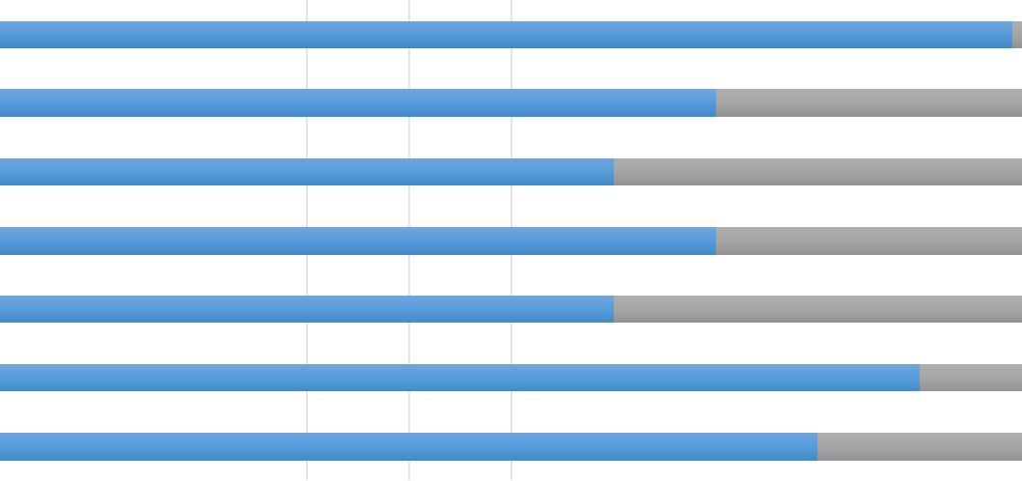

Interpersonal Skills: having a high sense of responsibility with excellent communication and interpersonal skills to work in a team and under the pressure also I’m a self-starter who takes initiative with minimal supervision.

LANGUAGES KNOWN:

- Arabic(native); fluent in both writing and speaking

- English; Excellent in both writing and speaking

ACHIEVEMENS AND AWARDS:

- Honored for conducting the best graduation project for the year of 2017 (The administrative capital for Hadhramout County).

- Certificate of achievement on MOOC Oil and Gas session 2017 (Exploration to Distribution) from IFP School Rueil-Malmaison, France

- Certificate from Ibin Sina'a secondary school for effective participation in the school activities.

TRAINING:
• | Amadeus Selling Platform GDS Airline System Mukalla ,Yemen | Sep 23-27
 |  | 2012

Participated for the second time in Amadeus refresher for system entries and Ticketing issues Amadeus GDS

- Galileo Travelport GDS Airline Global System, Mukalla, Yemen One week of training on system entries and Ticketing issues

- LEBANESE INTERANTIONAL UNIVERSITY, Mukalla, Yemen Course of intensive English language - 100 hours.

- SONA’A ALKARAR For human development , Mukalla, Yemen Diploma of Career Success and Administrative - 40 hours.

- Enviro-Spellathon from Environmental Research and Wildlife, Development Agency Abu Dhabi ,UAE

Jun- 2013

Apr, 2012

Jan, 2012

Participated at the environment marathon and get an excellent at level 5 | Dec, 2004

VOLUNTARY & WORK EXPERIENCE:

Participated in various activities such as:

- Human Project Mukalla, republic of Yemen participating in charity for poor people and help them

 | developed their lives to live better | Oct-Nov 2010
Experience:
1. | Participated in (Hope competition) for creating a new projects that make the city benefited
 | From it, the projects should be creative and not for personal needs, based in conditions
 | and terms. | 2010-2010
2. | Arabian Horizons Agency for Tour and Tourism (Agent For Qatar Airways in Yemen)
 | As sells and reservation agent in both Amadeus and Galileo GDSs | 2011-2012

- Apex Travel for Tour & Tourism Agency (Present)

 | As supervisor agent Using Amadeus GDS with TBO Holydays | 2012-2019
4. | Al-Hilali Establishment
 | As an Architect designing, planning, calculated the quantities and specifications | 2018-2019
5. | designing and planning several housing project

