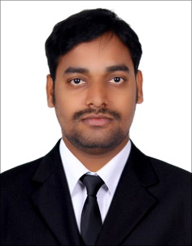
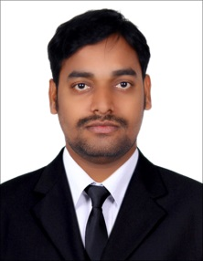
CURRICULUM VITAE
RAMESH
Email: ramesh-395656@gulfjobseeker.com
Dubai, UAE

OBJECTIVE:-
Intend to build a career with leading corporate of hi-tech environment with committed & dedicated people, which will help me to explore myself fully and realize my potential. Willing to work as a key player in challenging & creative environment.

PERSONAL INFORMATION:-
Date of birth : 12/06/1986
Nationality : Indian
Sex : Male
Marital status : married
Visa Status : Employment visa

PASSPORT DETAILS:-
Date Of issue : 17/08/2017
Date of Expiry : 16/08/2027
Place of Issue : India

EDUCATION DETAILS:-

- S.S.C Passed

COMPUTER SKILLS:-

- Knowledge of Computer, Ms Office, Internet Mailing & Surfing.

PROFESSIONAL EXPERIENCE:-
- Gemini studio working 6years exprince photo designer photographerdubai indoor &outdoor delivery boy

LINGUISTIC KNOWLEDGE:-
- English
- Hindi
- Telugu

STRENGTH & ABILITIES:-
- Commitment towards jobs
- Ability to learn quickly
- Hard working Mentality

DECLARATION:-
I do here by declare that the above given details are true and accurate to the best of
My knowledge.
Ramesh

