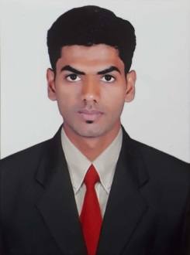
CURRICULAM VITAE

AZHAR

Email: azhar-395665@gulfjobseeker.com

Objective
To secure position in your organization that will utilize my talent, challenging my skills & offer me opportunity to grow both personally & professionally

STRENGTH
Optimistic in my nature it is my higher strength.
I can adopt my self in any situation.

COMMUNICATTIVE
Learning how fascinates being a flexible person. Can adopt to any given situation ability to thank critically and act logically to evaluate situation solve problem and make decision.

EDUCATIONAL QUALIFICATION
Course | Name of institution | Year
B.com | Government First Grade College Channapatna | 2015
P.U.C | Government Pre University College for Boys Channapatna | 2012
S.S.L.C | Government Boys High School Channapatna | 2010

EXPERIENCE :
1.1 Years Experience as a sales Executive in SBI Credit Card Bangalore.
2. 1.6Years Experiencein professional loan sales as a assistant manager in Bajaj finance ltdBangalore.
3. 3 months Experience asa cashierin tamdeenentertainment company (Kuwait)
4. 6 month Experience as Host in IMG World's of adventures
QUALIFICATION IN GENERAL
Computer Fundamentals.
Microsoft office proficient, Word, Excel, Power Point, Outlook, Internet research expertise, Tally EXP 9.0

HOBBIES
Reading Books, Playing Cricket,
Learning Tactics to motivate the people

Personal details
Date Of Birth : 15/10/1993
Nationality : Indian
Gender : Male
Religion : Muslim
Marital Status : Single
Language Known : English, Urdu, Kannada & Hindi
Haight : 6 ft

Passport Details
Date of Issue : 12/01/2016
Date Of Expiry : 11/01/2026
Place of Issue : Bangalore

Declaration:
I hereby declare that the above given information is true and correct to the best of my knowledge and belief.

Date:
Place: Channapatna (Azhar)

