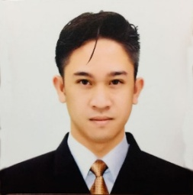
RR
Dubai, UAE
rr-395676@gulfjobseeker.com

OBJECTIVE
To secure an IT Service Management role in a challenging workplace that welcomes innovative ideas and offers growth opportunities and positive environment.

SKILLS
- Computer Hardware Repairing
- Computer Software Repairing
- Internet Troubleshooting
- Photo Editing
- Video Editing
- Proficient in Microsoft Office
- Database Administration
- Troubleshooting

WORK EXPERIENCE
- Office Staff/IT Admin
Green Estate Realty & Development Corp.
(June2018-March2019)
- Operations & Management (Family Business)
(2017-2018)
- Computer Technician/PC Repair (Home based)
(2012-2017)
- Encoder (Home based)
(2011-2014)

On-the-job Training:
- Tech Support/MIS, Infuturo Inc.
(486 hours) (May 2017 – September 2017)
- Computer Technician, Dackz Computer Shop
(300 hours) (2012)

EDUCATION
Colegio de San Juan de Letran – Manaoag, PH
- Bachelor of Science in Information Technology, 2018
- Computer Hardware Servicing II, 2012

Academic Achievements:
- Best in Web Development, 2018
- Best in Research Paper, 2018

