(FEB2018 to JUL2019)
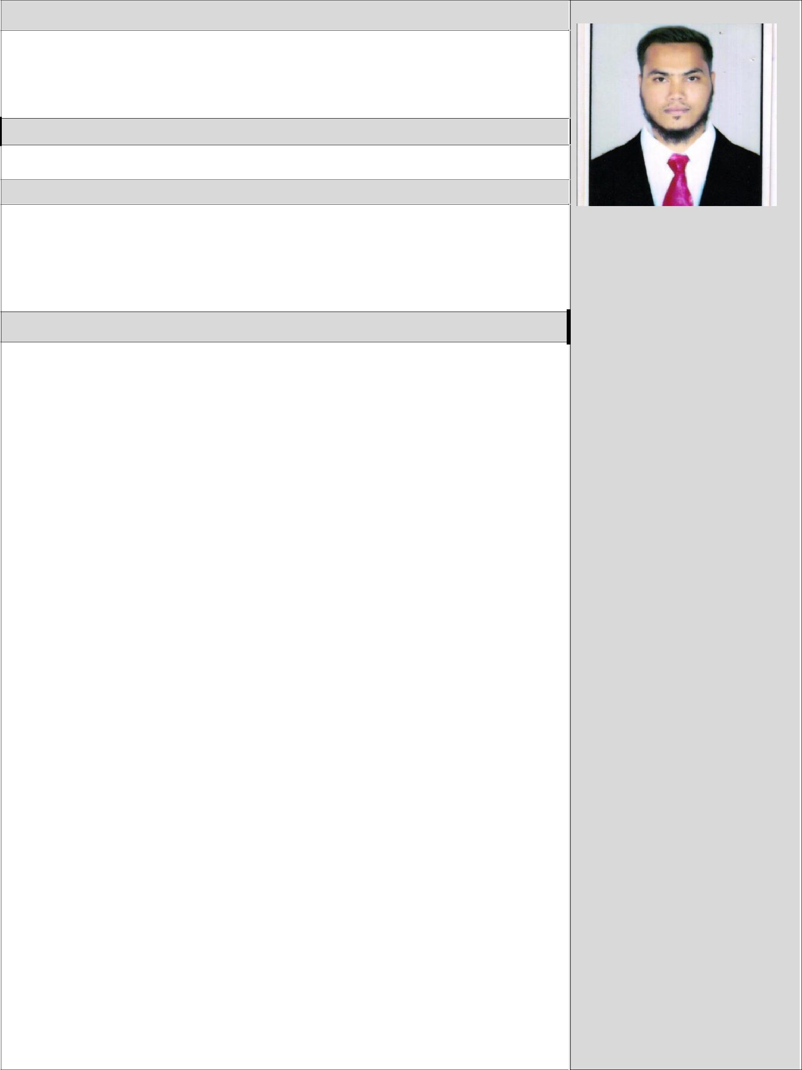
CAREER OBJECTIVE

Looking for a challenging and demanding position in HVAC systems design, maintenance, installation & commissioning in a growth-oriented HVAC/Electro-Mechanical consulting/contracting/construction organizations where there is scope for individual and organizational growth.

PROFESSIONAL EXPERIENCE: TOTAL EXPERIENCE (1.5 YEARS)

HVAC Site Engineer

PROJECTS

State Street financial services limited.
Conduent business service India pvt ltd.

JOB RESPONSIBILITIES:

- Get approved HVAC shop drawings, MEP coordination drawings, work method statement and project specification from project engineer.

- Ensure HVAC ducts, fittings, accessories and chilled water pipes, fittings, accessories are available and approved by inspection department prior to installation.

- Ensure sufficient hand tools, power tools, ladder and scaffolding are available for installation.

- Coordinate with other discipline and ensure site clearance is available to start the HVAC activities.

- Arrange the sufficient man power such as supervisor, foreman, duct fitter, pipe fitter etc and ensure all of them attended safety orientation and start installation activities at site.

- Provide approved HVAC shop drawing, MEP coordination drawing to site supervisor (or) foreman and inform them to shift the required ducting and piping approved material from warehouse to site and arrange required material to avoid progress delay.

- Prior to start HVAC activities notify to QC personal for surveillance to ensure the quality work.

- Closely monitor site activities to ensure quality work is in compliance with approved shop drawing and specification get daily progress report from supervisor and update to Project Engineer (or) Manager.

- Active involvement in weekly meetings with the project management and QC manager to resolve the site related issues.

- Assist the commissioning team in commissioning stages of all HVAC

Equipment’s.

- Planning every service of the project in advance to hand over the project in required date

- Assist the project engineer during preparation of final test reports, as built drawings, operation and maintenance manual and handling over the project to client.

RIZWAN
(Available in UAE)

Email:
Rizwan-395690@gulfjobseeker.com

Personal Details:

Date of birth: 4 Aug 1994.
Sex: Male.
Nationality: Indian.
Marital status: Single.

Languages: English, Hindi, Urdu, Kannada.

COMPUTER SKILLS:

- MS Word,MS Excel
- AutoCAD.
- HAP.
- Operating systems windows 98, XP, 7, 8, 10

PERSONAL TRAIT:

- Comprehensive problem solving.
- Willing to learn.
- Good communication skills, flexible & Ability to deal with people.

- Understanding different concept & type of work.

- Understanding Technical Specifications.
- Proactive and willing to take on new challenges.
- Work effectively under pressure.
- Manage and monitor each stage of project.

- Complete assigned tasks within time.
10 Leadership qualities & believe in team work.

EDUCATION QUALIFICATIONS:

 | Bachelor’s in mechanical | 2017 (B.E) (60%)
 | engineering
 | Pre-university college | 2013 (PUC) (65%)
 | Secondary school examination | 2011 (SSLC) (58%)

CERTIFICATION:

Myself Certify that the following information submitted by me is true to best of my knowledge. False information may reveal me to disqualification from my services if Employed.

Place: DUBAI, UAE

Yours Sincerely,

RIZWAN

