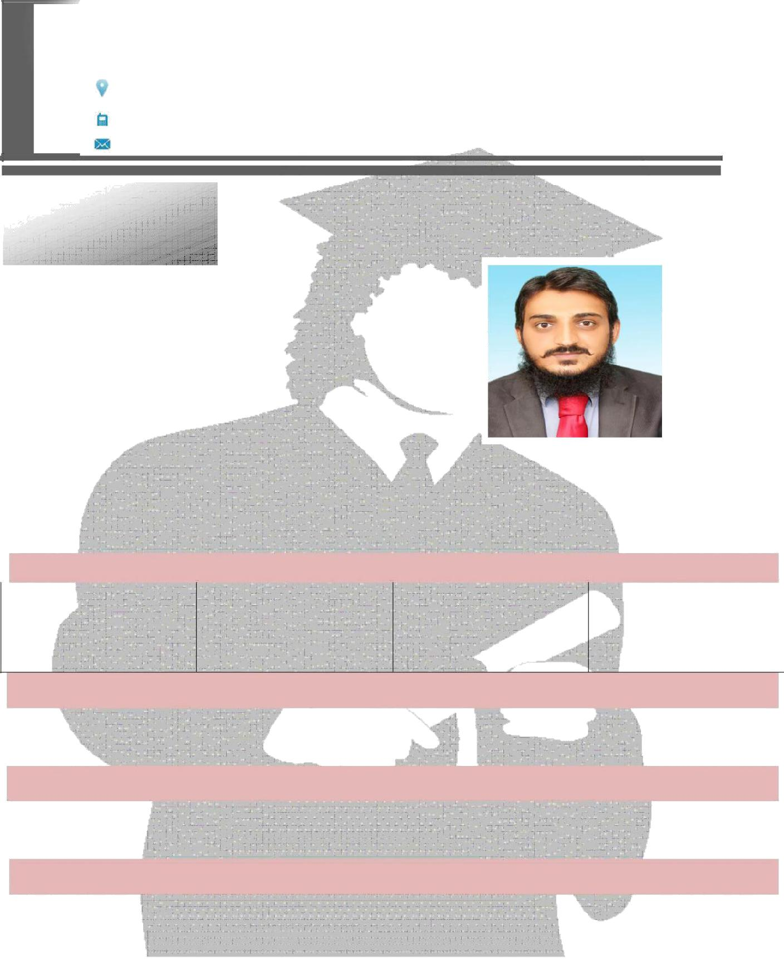

Zakaria

Zakaria-395697@gulfjobseeker.com

Personal
Information:

Date of Birth | : | 04/02/1994
Gender | : | Male
Religion: |  | Islam
Nationality | : | Pakistani
Domicile: |  | MARDAN

 | ACCADMIC QUALIFICATION
 | EXAMINATION | YEAR | MARKS | BOARD
SSC |  | 2010 | 808/1050 | BISE MARDAN
F.Sc |  | 2012 | 744/1100 | BISE MARDAN
B.Sc. Electrical ENGG |  | 2017 | 2.65 CGPA | CECOS UNIVERSITY

COMPUTER Certificate:

✓ Microsoft Office 

- ✓ Adobe Photoshop  
EXPERIENCE

- Experience of New Embedded devices & microcontrollers such as Arduino, etc.

- Have Command on, Internet, Ms. Office, Adobe Photoshop,

Window’s and English Typing as well.

Languages:

LANGUAGE
Urdu, English, Pashto.

