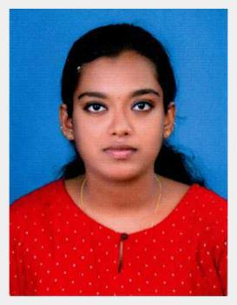

INDHU
E mail: indhu-395726@gulfjobseeker.com

Career Objective

I am looking for a career and challenging job in a professional environment, where I can utilize my skills, knowledge and were I can grow and learn. And excel in various dimensions while contributing my best.
Educational Qualifications

 Diploma (civil Engineering)

From Anna University

March – 2018

 SSLC

From Board of Public Examinations, Kerala

March – 2013

Additional Qualifications

- Master Diploma in Building design (National Skill Development Corporation of India)

- AUTOCAD

- 3DSMAX

- PRIMVERA

IT Skills

❖ Operating Systems: | Microsoft Windows XP, 7 , 8 and 10
❖ Office Applications: | Microsoft Word and Microsoft Excel
❖ Mailing Systems: | Email and Outlook express
Languages known
English, Hindi , Malayalam and Tamil

INDHU
Work Experience
- Presently working in CNS Constructions as Draughtsman

Key Strengths
- Ready to work in new field and learn new technology

- Young, mature attitude and able to work in a multinational environment and dealing with people at different level

- Highly motivated with strong work ethics to contribute to a progressive organization.

- Fast adaptability to any situation and willing to take responsibility.

- Flexible, reliable and dedicated.

Personal Details
Date of Birth: | 04-07-1997
Sex: | Female
Marital Status: | Single
Nationality: | Indian
Passport Details
Date of issue: | 04-06-2019
Valid up to: | 03-06-2029

DECLARATION

This is to certify that the entries made are true to the extent of my knowledge and belief

Place : Kollam
Date : 13-08-2019

INDHU

