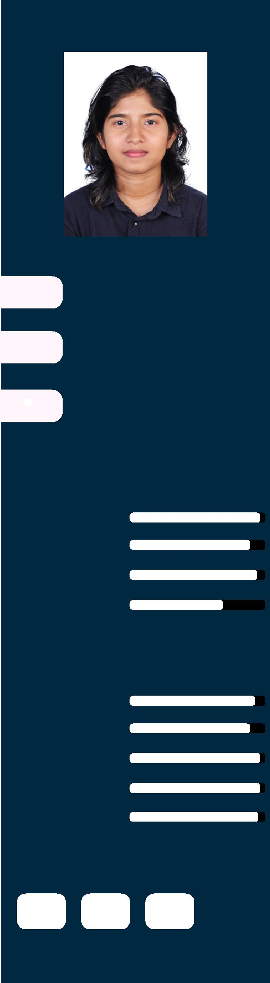

CONTACT

- Maduri-395732@gulfjobseeker.com



SKILLS

Graphic Design

Drawing

Type Setting

Hardware

MADURI

GRAPHIC DESIGNER

Highly creative and multi talented Graphic Designer with extensive experience in print design

PERSONAL INFORMATION

Born : 1997.10.19

Gander : Female

Nationalty : Sri Lankan

Working gives me a lot of skills and experience that I believe make me best suited for the job position that is being offered with a position of Graphic Designer.

EDUCATION

2013-2014 Graphic Designing Course
Wijeya Graphics (Pvt) Ltd, Negombo, Sri Lanka

2002-2013 High School
Loyala Collage, Negombo, Sri Lanka

WORK EXPERIENCE

SOFTWARES

Photoshop

Illustator

Indesign

Coreldraw

Microsoft Office

HOBBIES

2016-2019 Akura Printers & Publishers
Graphic Designer

Maintained to different type projects (Novels,

Revision Papers, Short Notes, Story Books) etc
Skilled with adobe creative suite (illustrator,
Photoshop, Indesign and Microsoft suite.

2016-2018 Radiant Graphics
Freelance Graphic Designer

2015- 2016 Master Graphics (PVT)Ltd
Graphic Designer

To Create different format, bill books for government
 N  µ Companies, Private Companies etc and projects of Master Graphics.

