SETHU

UI/UX Designer

sethu-395755@gulfjobseeker.com

EXPERIENCE

______________________________________________________ User Experience Designer - Wipro Ltd
Bangalore, INDIA. May 2013 - July 2019

Develop the Visual Interface Design through personas, storyboards, scenarios, mood boards, iconography, and illustrations.

Research and analyze user behavior using qualitative methods, and a subset of quantitative methods, to inform design. Build prototypes to assist in user research, using low- to high-fidelity techniques.

............................................................................................................

Visual Designer- One Mind Group

Chennai, India. August 2012 - April 2013

A visual and verbal storyteller, delivering insights about people and behavior in a way that generates empathy, emotion, and engagement from the client and design team.

............................................................................................................

Graphic Designer- Redpack Brand Design

Bangalore, India. July 2008 - June 2010

Participate as a contributor to an interdisciplinary team that includes other designers, program management, business and brand strategists, and hardware and software developers to create high-quality packaging designs and branding for consumer goods.

TECH STACK

______________________________________________________

Photoshop Illustrator InVision Axure RP Sketch

Adobe XD HTML5 CSS3 InDesign Dreamweaver

SKILLS

______________________________________________________

• User Research • Usability Testing

• Information Architecture • Design Thinking

- Wireframing & Prototyping

LIFE PHILOSOPHY
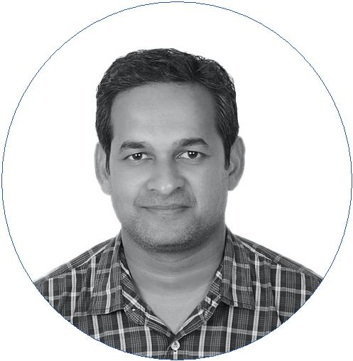
______________________________________

“Bring a vision make an impact, I rely on empathy, nurture collaboration and stay transparent”.

EDUCATION

______________________________________ Diploma in Graphic Design

TAFE Queensland ( GoldCoast, Australia) July 2010 - July 2012

MOST PROUD OF

______________________________________ Working with stakeholders

Work closely with development teams to ensure that design specifications are implemented.

Attention to detail

Passionate and enthusiastic about excellence and attention to detail.

Taking challenges

Professional, flexible, and able to succeed in a rapidly changing environment.

PASSIONS

______________________________________

Movies Running

Travel Healthy Living

