OBJECTIVE
CURRICULAM VITAE

Seeking an objective for professional growth and increasing responsibility as a professional in an organization where team spirited personal skills are recognized and rewarded.

WORKING EXPERIENCE

Akhilesh
Akhilesh-395818@gulfjobseeker.com

PERSONAL PROFILE
Date of Birth :- 27/12/1996 Gender :- Male Marital Status :- Single Nationality :- Indian Religion :- Hindu
- In India (experience, Apr.2019 to Nov.2019). Position: Site Supervisor
- Group of company(1.5 year experience, Sep. 2017 to Feb.2019)
Position : Site Supervisor
- Designing & Consultancy (1 year experience, Aug. 2016 to Aug. 2017)
Position : Site Supervisor & Drawings

ACADAMIC RECORD

- Diploma Civil Engineering(2014-2016) ICE ( Institution of Civil Engineers ) Universal College of Engineering, Payyannur.

- Higher Secondary (2012 -2014) (Board of higher secondary examination in Kerala), GOVT
H.S.S Morazha, Kannur.

- SSLC (2012)
(Board of public examinations in Kerala) GOVT H.S.S Morazha, Kannur.
(1.5 year experience).

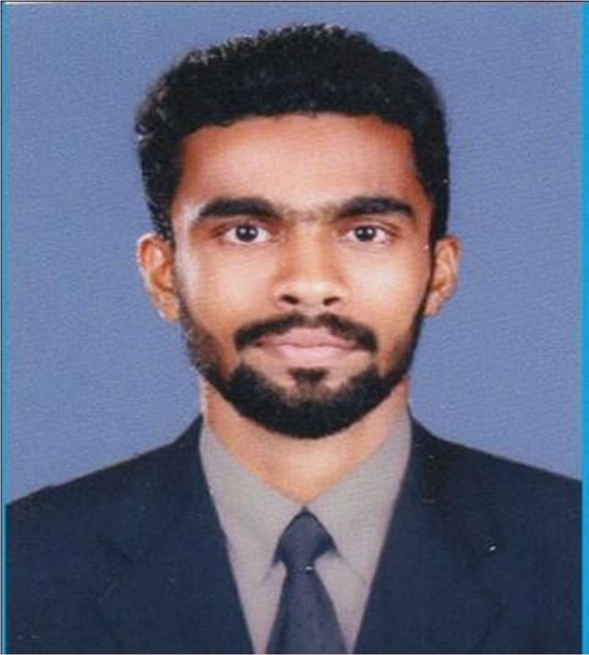

TECHNICAL SKILL

  - AutoCAD, 3Ds max, Revit
(1 year
  - MS office
  - Uses of Internet and Mailing

L INGUISTIC ABILITY
D UTIES & RESPONSIBILITIES

Languages:-

English
- Speaking
- Writing
- Reading

Malayalam
- Speaking
- Writing
- Reading

Hindi
- Speaking
- Writing
- Reading
- Over all site management and planning
- Quality control of concrete works and all civil works.
- Preparation of Quantities.
- Calculating the weight of steel structures.
- Correspondents & Co-ordination with client and Consultants.
- Execute all type civil works ( RC Foundations, Grade beams, columns, core walls, water tanks, roof slab and finishing works )
- Overseeing the selection and requisition of materials and plant
- Resolving any unexpected technical difficulties and other problems that may arise
- Preparing reports as required

DECLARATION

I hereby declare that the above details are true and correct to the best of my knowledge and belief.

AKHILESH

