Akhil-395833@gulfjobseeker.com

EDUCATION

MECHANICAL ENGINEER

PPG Institute of Technology, Coimbatore,India
TECHNICAL SKILLS

HAP
PLAN SWIFT
MEP
MS OFFICE

2015 – 2018
UNIVERSITY

ANNA UNIVERSITY, CHENNAI
PERCENT- 63.2%

PERSONAL PROJECTS

DESIGN AND FABRICATION OF TRASH REMOVAL MACHINE (2018)

DIPLOMA IN MECHANICAL ENGINEERING
Christ The King Polytechnic, Coimbatore,India
Waste Management System

MULTI WHEEL TIGHT NUT TIGHTNER AND LOOSENER

2011 – 2014
UNIVERSITY
ANNA UNIVERSITY-
Department of Technical Education, Chennai

HIGHER SECONDARY EDUCATION
S.N.H.S.S, Parvoor,Kerala,India
2009 – 2011

10th STANDARD EDUCATION
PERCENT-66

PERCENT-76%

(2014)
Automobile, Maintenance and Repairing

VISA DETAILS

Date of Expiry: 22/08/2028 Date of Issue: 23/08/2018 Visa Status : Visit Visa

Little Flower Higher Secondary School,
Njarakkal,Kerala,India

2009
PERCENT-76%

CERTIFICATES

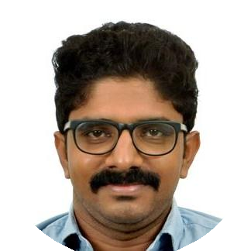

AKHIL
MECHANICAL ENGINEER
An independent and self-motivated aspiring engineer who wishes to conquer the realms of knowledge. Conﬁdent leader and enthusiastic communicator.
WORK EXPERIENCE

Professional Experience

In Kerala,India
06/2018 – 08/2019
Ship repair, Ship Building,Quality Control Tasks

SITE ENGINEER

Professional Experience

Cochin Shipyard Limited, Kerala,India
05/2014 – 04/2015
Task:

SITE ENGINEER

INTERNSHIP

Cochin Shipyard Limited,Kerala,India

INDUSTRIAL VISIT
Hindustan Machine Tools Limited, Bangalore,Karnataka,India

ERNAKULAM

ERNAKULAM
Creativity and Innovations

IELTS(2019)

LANGUAGES

ENGLISH
Full Professional Proﬁciency

HINDI
Full Professional Proﬁciency

SOFT SKILLS
Leadership

Team Work

Problem Solving

MALAYALAM
Full Professional Proﬁciency

TAMIL
Professional Working Proﬁciency

Constant Learner

