SOORYA TEACHER

Summary

Seeking a challenging career with progressive result oriented organization which offers ample opportunities to Boost my career to serve the organization where I am absorbed.

Contact Information Career History

Dubai,UAE

Soorya-395870@gulfjobseeker.com

Personal Skills

Good Verbal and Written Communication Skill
- Ability to deal with people diplomatically
- Willingness to learn
- Comprehensive problem solving abilities
- Leadership quality

Personal Information
Higher Secondary School in Thalassery, India (June 2018 – March 2019) Role: Class Teacher

English Medium High School in Panoor, India from (May 2019 – August 2019) Role: Class Teacher
RESPONSIBILITIES

- Prepare classroom for class activities.
- Identify and select different instructional resources and methods to meet students varying needs
- Instruct and monitor students in the use of learning materials and equipment
- Observe and evaluate students performance and development
- Assign and grade class work, home work, tests and assignments
- Encourage and monitor the progress of individual students
- Maintain discipline in accordance with the rules and disciplinary systems of the school
- Keep updated with developments in subject area, teaching resources and methods and make relevant changes to instructional plans and activities.

Nationality: Indian
Visa Status: Residence Educational Qualification

Marital Status: Married

Date of Birth: 30/08/1994

Projects
Paper Presentation Presented the paper in the National Seminar on Gender Equality and Social inclusion in the contemporary
India: issues and challenges
- B.Ed {Malayalam} Kannur University

Academic Qualifications

- M.A Malayalam Kannur University, India

- B.A Malayalam Kannur University, India

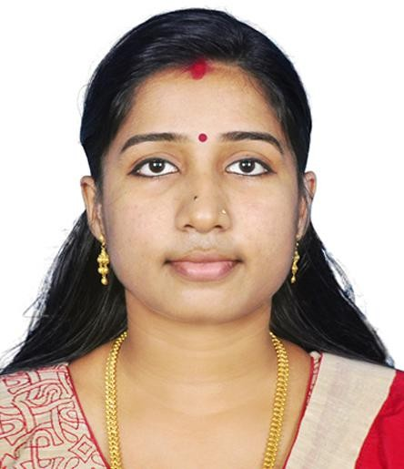held at Government Bernnen  Plus Two Board of Higher Secondary , Kerala, India
College of Teacher Education S.S.L.C Board of public Examination , Kerala, India Thalassery
Attend The Paper Participated Seminar on intangible Cultural Heritage Of India at Dr.P.K. Rajan Memorial Campus Nileshwaram

Language Known English Malayalam
Hindi

Place: Dubai Date:
Other Skills

  - Tally Accounting
  - Microsoft Office

Personal Interests
  - Listening Music
  - Dancing
  - Gardening
  - Cooking

Declaration

I hereby declare that all the above furnished statements are true to the best of my knowledge and belief.

Referees

Available upon request

